SOP4: Quantification of methane and nitrous oxide via the purge-and-trap method
Authors so far: Sam Wilson, Bonnie Chang, Jan Kaiser, Gregor Rehder

1.0 Background to the purge-and-trap method
The analysis of CH₄ and N₂O in seawater using various gas extraction techniques has been occurring since the 1960s (e.g. Swinnerton et al., 1962). The inclusion of a cold-trapping step in the methodology was subsequently added to increase the analytical sensitivity (Cohen, 1977; Lilley et al., 1983; Cline et al., 1987). Since then, the design of purge-and-trap analytical systems has become fairly well-established and while some of the components have been updated, the concept and practice of the method have remained largely unaltered. In comparison with the equilibration analysis (Chapter 6: Headspace equilibration method), the purge-and-trap method is less commonly employed due to a more intricate set-up, a longer time for sample analysis, and the complexity of establishing automated procedures. However, there are several advantages to the purge-and-trap method including its higher sensitivity enabling low concentrations to be analyzed and the ease of calibrating over a wider range.
Currently, several laboratories employ purge-and-trap methods for measuring CH₄ and N₂O (e.g. Zhang et al., 2004; Bullister and Wisegarver, 2008; Capelle et al., 2015; Wilson et al., 2017). Most of these publications contain detailed methodological information specific to a particular setup. Every laboratory has slightly different set-up of the purge-and-trap method due to differences in sampling. For example, Bullister and Wisegarver (2008) manually inject the seawater sample using a large volume syringe which avoids the need for displacement of the seawater from a sample bottle as per the method of Wilson et al. (2017). The authors Capelle et al. (2005) established an automated system for the analysis of crimp sealed bottles. It is not known to what extent these differences in methodology cause analytical variability in measured concentrations.
A brief summary of the purge-and-trap method involves the transfer of the seawater sample from a bottle or syringe to a glass purge chamber fitted with a porous frit. The seawater is sparged with an inert gas and the gaseous contents of the seawater sample are trapped at low temperatures. The cold trap is subsequently rapidly heated and the contents transferred to an analytical column housed within a typical gas chromatography setup. Multiple 6-port switching valves with calibrated sample loops are located upstream of the purge chamber to enable calibration of the entire analytical system (see Chapter 2: Calibration of methane and nitrous oxide).

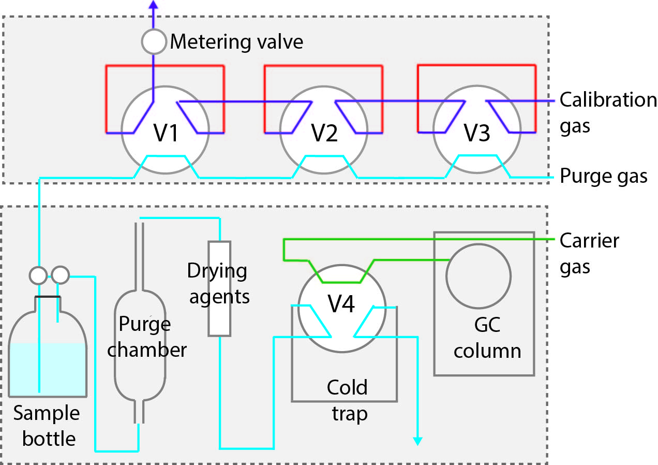
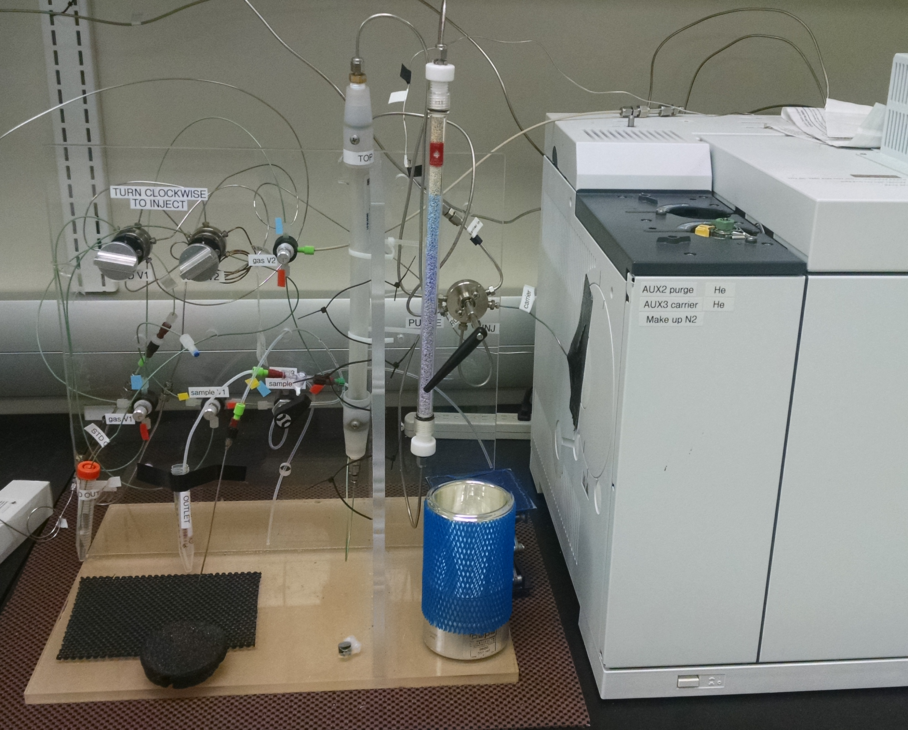

Figure 1. Overview of the purge-and-trap set up. The calibration loops are installed prior to the purge chamber which is connected to the coldtrap via multiple drying devices. The purge-and-trap setup is directly connected to the gas chromatography unit. All items and fittings are gas tight and typically use 1/16” stainless steel tubing or PEEK tubing if necessary.

2.0 Analytical Procedures
2.1 Purging the seawater sample
The seawater sample needs to be transferred from either a bottle or syringe (see Chapter 1: Sampling) to the purge chamber while avoiding the loss or contamination of the sample. Safeguarding sample integrity is achieved by avoiding exposure to the ambient atmosphere and excluding the use of permeable or contaminant materials in the tubing or fittings. When transferring from a syringe, the plunger is pushed to inject the sample. When transferring from a bottle, the seawater sample is pushed into the purge chamber under positive pressure supplied by an inert gas (helium or nitrogen). The volume of sample injected depends upon the analytical setup and ranges from 10–200 ml. It is important that the sample volume is quantified to a high accuracy and this is achieved either by calibration of the syringe or weighing the sample post analysis.
The seawater samples can enter the purge chamber through either a small side-arm or through the bottom of the purge chamber (Figure 2). Entry of the purge-chamber through the side-arm avoids the seawater sample passing through the porous frit. This is preferable for samples with high particle content as the frit can otherwise become clogged. The other consideration for the purge chamber is the overall volume, with particular consideration for the size and length of the exit tube. The sparging will cause the gas escaping the purge chamber to have high moisture content and mitigation of water droplets entering the set-up is highly desirable. It is important that when the purge gas is purified even if ultra-high purity gas is being used as CH4 can be present in trace quantities that will accumulate in the main cold trap described below. Purification of the purge gas at the University of Hawaii is achieved by passing it through stainless steel tubing packed with Porapak Q and immersed in liquid nitrogen.

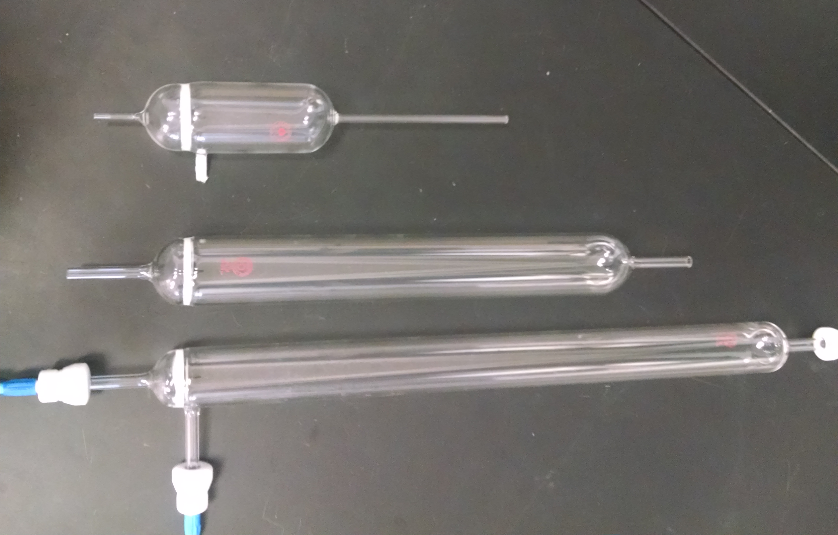
Figure 2 Purge chambers come in a variety of shapes and sizes. The size is primarily dependent upon the volume of sample that needs to be purged. Many purge chambes have a side-arm which allows the entry/exit of the seawater sample without passing through the frit. The glass frit has a nominal pore size of 10–20 μm (Porosity D; AceGlass).

The purging efficiency is determined by flow rate, gas pressure, and length of purge time, and should be verified for each individual set-up (Figure 3). Most systems operate at a flow rate of 100–200 ml min⁻¹ with a purge time of ≤10 mins. The purging efficiency for water samples can be estimated by varying the length of purge time for replicate seawater samples and also by re-purging a water sample following the initial extraction. The amount of dissolved gas collected on the second extraction is an indication of the fraction remaining. Ideally the stripping efficiencies for all components should be greater than about 99% to minimize the size of the required corrections.

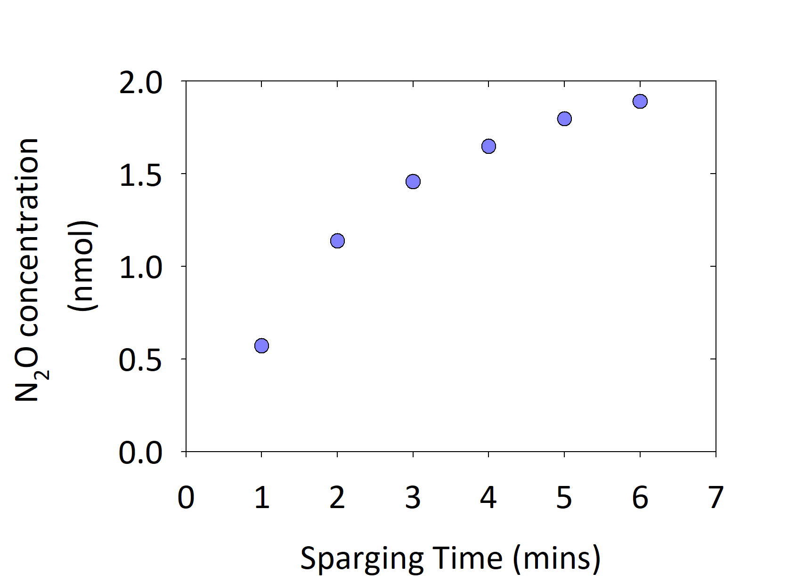
Figure 3. Example of sparging efficiency as measured for N₂O with the analytical system used by NOAA PMEL (Bullister et al., 2003). A 200 ml seawater sample was sparged with N₂ at 150 ml min⁻¹ and an ambient temperature of 20°C.

2.2 Step-by-step procedures for the transfer of a seawater sample from a crimp sealed bottle into a purge chamber
One of the most common sampling procedures is to collect the seawater sample in a crimp sealed vial. The following step-by-step procedures describe the individual steps used to transfer the seawater sample from the bottle to the purge chamber without exposure to the ambient atmosphere. At the end of the analytical run, the sample is drained from the purge chamber.
Step 1. Ensure the system is in standby mode
Step 2. Insert the seawater outlet needle all the way to the bottom of the glass bottle. A 22 gauge needles is used with an outside diameter of 0.025 inches (0.64 mm) and a length of 3 inches (76 mm). Avoid injecting the needle through the ‘feet’ of the septum as this will be hard to penetrate.
Step 3. Switch V2 to inject. This will divert the helium purge gas to flowing out of the inlet needle and vent any ambient air inside the tubing. Then insert the gas inlet needle to just inside the septum. The sample will flow into the waste receptacle at the back of the prep system. Let it flow for ~10 sec in order to flush the transfer lines
Step 4. Switch V3 to inject the seawater sample into the purge chamber. It is not recommended to inject the whole volume as the transfer lines should always be filled with the sample during this procedure.
Step 5. Switch V2 and V3 back to standby mode and begin the purging.
Step 6. To drain the purge chamber at the end of the sample run, it is necessary to reverse the flow through the purge chamber and retrieve the purged sample. This requires switching V1, V3, and V4. Remove the needle from the septum and insert into an empty flask. The sample can now be weighed if a sampling bulb is not incorporated into the analytical design. After the sample has fully drained, return the valves to Standby mode.

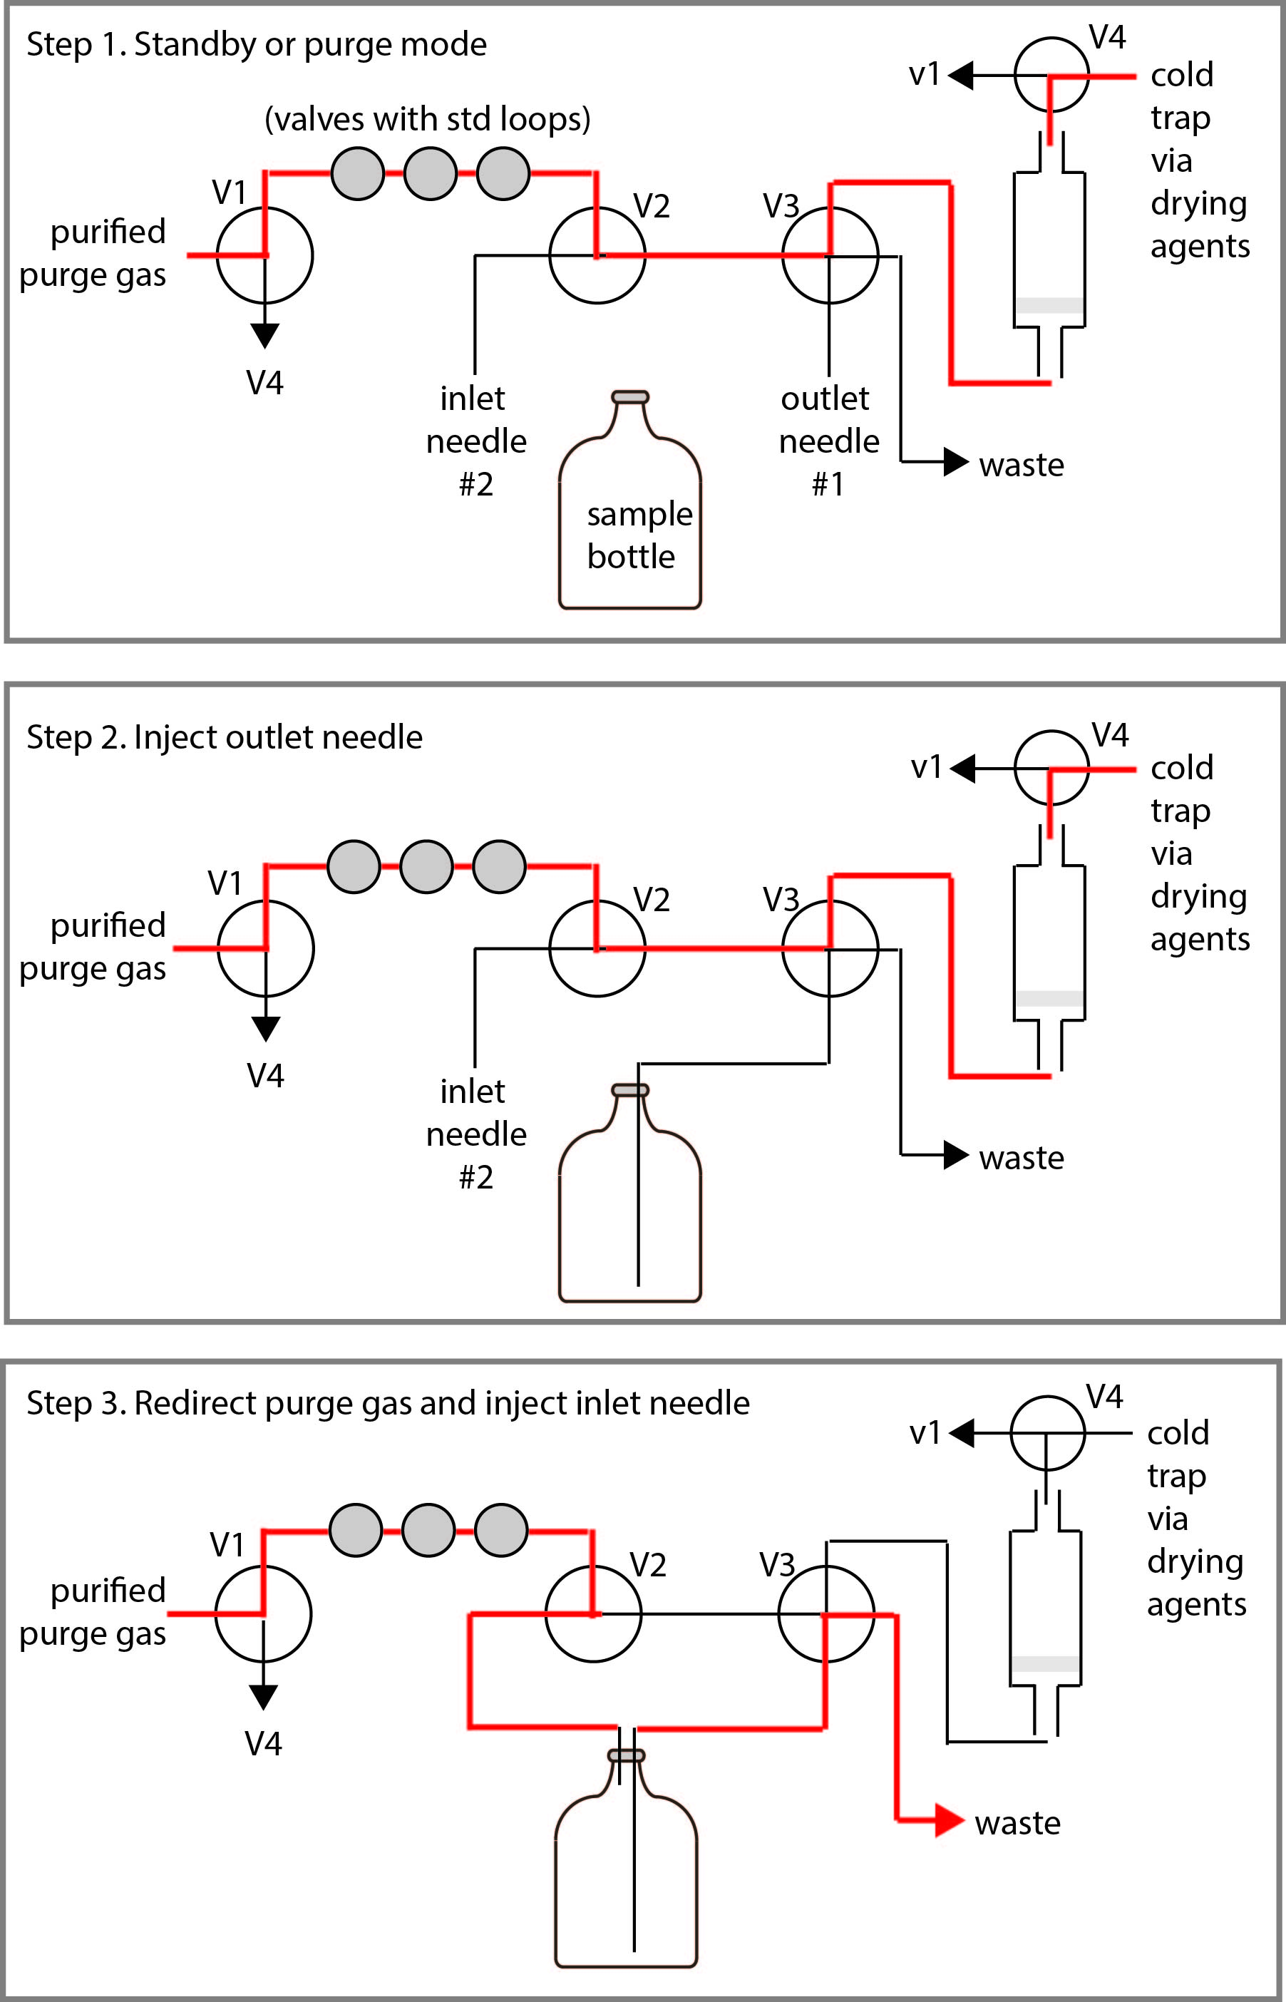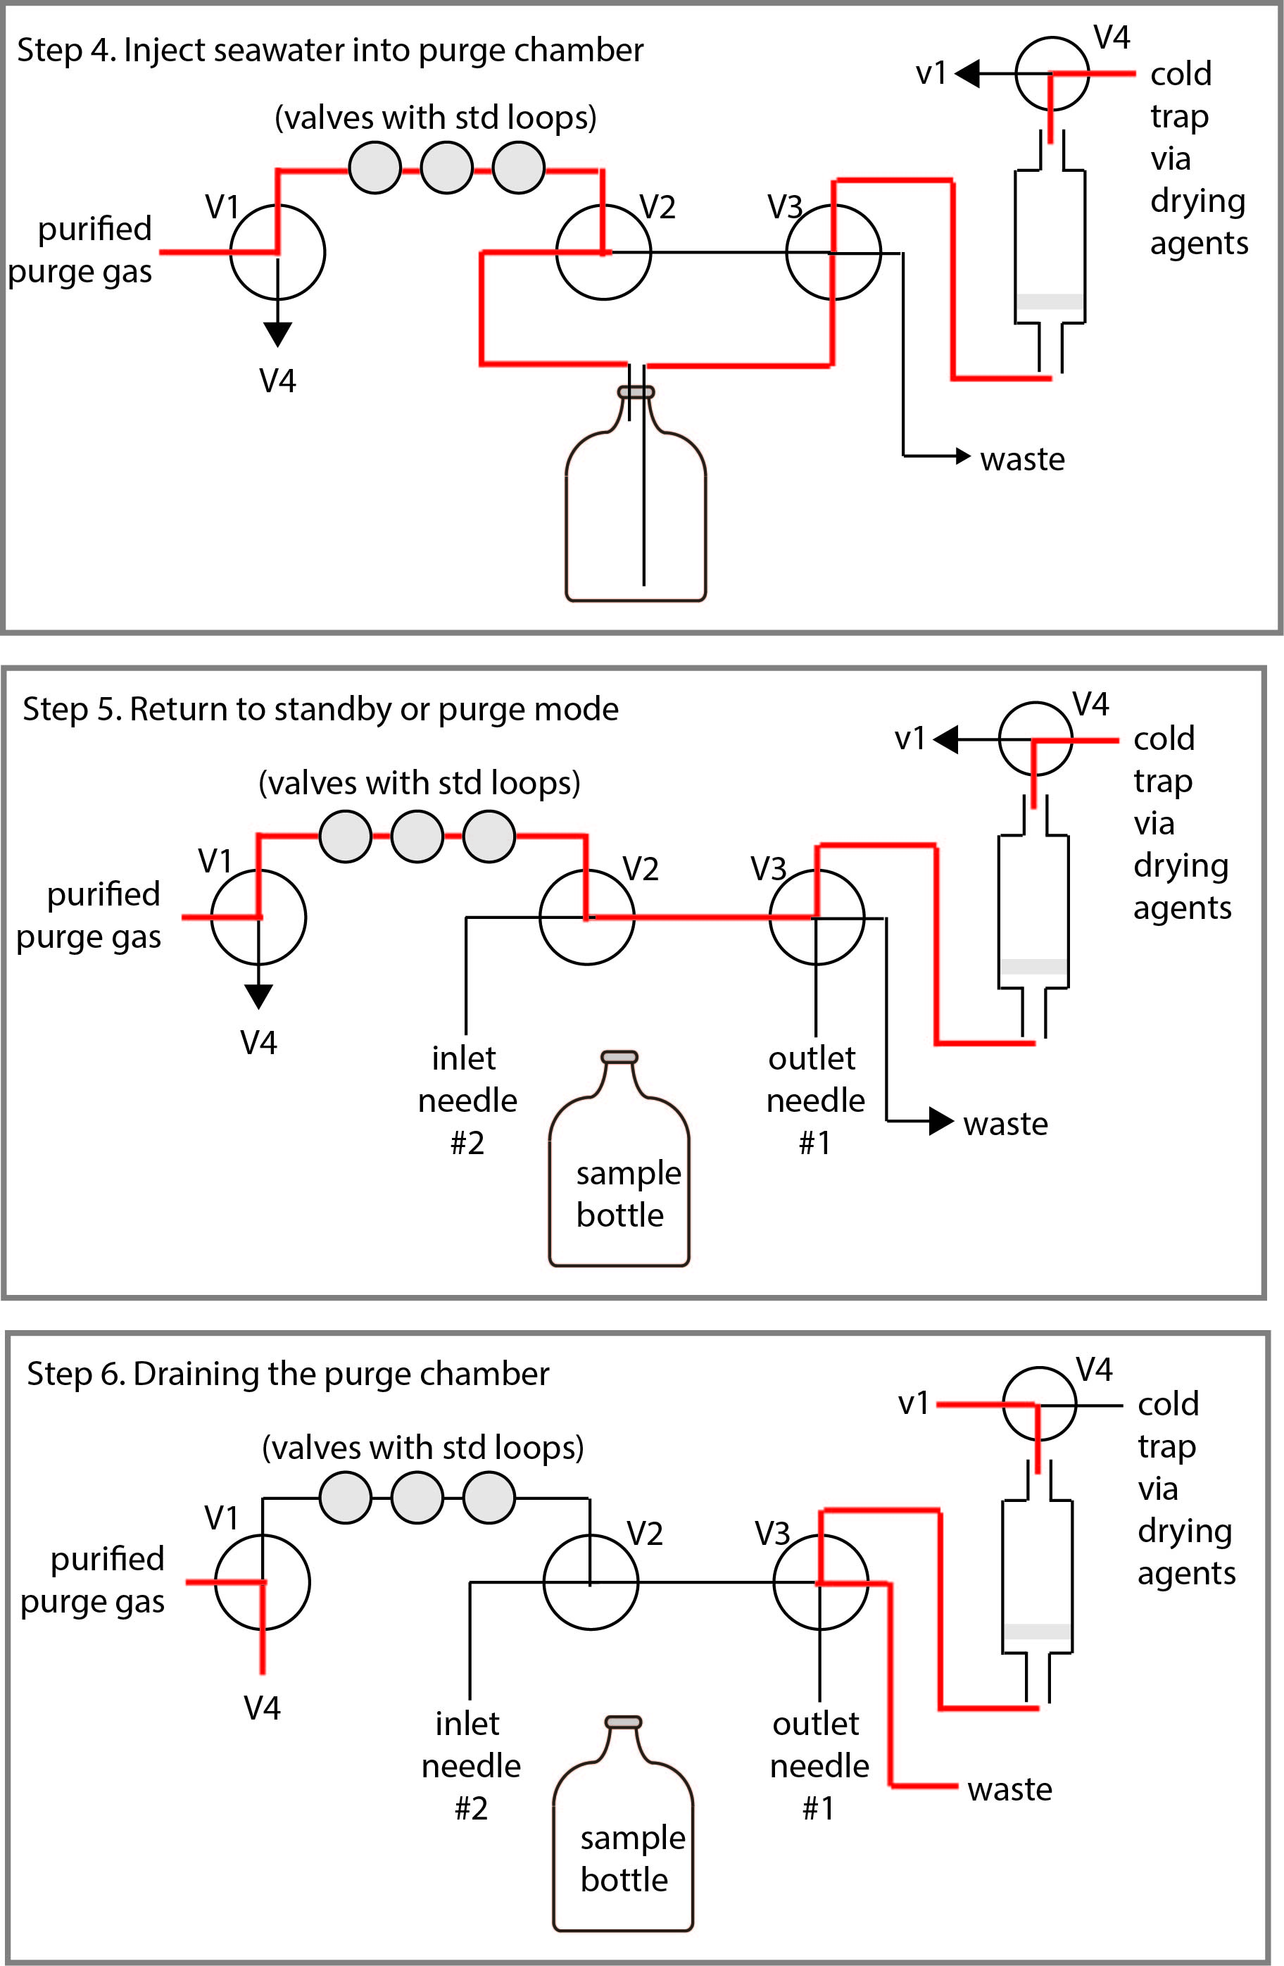

Figure 4. Step-by-step procedures to transfer seawater from a sample bottle to a purge chamber, as used at the University of Hawaii (Wilson et al., 2017).

2.3 Drying the gas stream
While an appropriately designed purge chamber can mitigate the passage of large water droplets, it is important to ensure that all water (droplets and vapor) is removed after the purging and before the trapping process. To achieve this, multiple drying devices and agents are installed on the gas lines between the purge chamber and the cold trap. It is common to have a small plug of glass wool located close to the exit port of the purge chamber to prevent large water droplets passing along the gas line. The next drying agent is often a Nafion® drier (Perma Pure LLC) which should have a flow rate 2-3 times that of the sample flow rate. The final drying agent is indicating CaSO₄ trap (e.g. Drierite, VWR) or magnesium perchlorate (Mg(ClO₄) which is typically installed with a small amount of sodium hydroxide adsorbed on silica (e.g. Ascarite) to remove carbon dioxide that will otherwise interfere with the chromatographic analysis of N₂O. Correct installation of the drying agents as outlined above allows the Drierite to be replaced every few months with continual use. When installing the drying devices, it is important to use gas-tight procedures and to ensure that they do not interfere with the integrity of the sample. It is helpful that the Drierite and Ascarite are contained within a glass tube so that they can be visually inspected for absorption of moisture.

2.4 Cold-trapping
Nitrous oxide and methane are cold-trapped onto a packed sample loop (Figure 5). The sample loop packing material is typically Porapak Q 80/100 (Sigma-Aldrich), although HayeSep provides a comparable retention. Some commercial companies offer a packed column for purchase and this can be a preferable to hand-packing a loop in the laboratory, especially for sample loops with a 1/16 inch (1.6 mm) diameter. The packed loop forms part of a 2-position 6-port switching valve that can be manually or electronically operated. In one position the loop is connected to the purge chamber and in the second position, the loop is connected to the analytical column. Cryotrapping is achieved for methane using liquid nitrogen (-195°C) and either liquid nitrogen or cooled ethanol (-70°C) for nitrous oxide. The loop can be heated by immersing in hot water or by running an electrical charge through it.
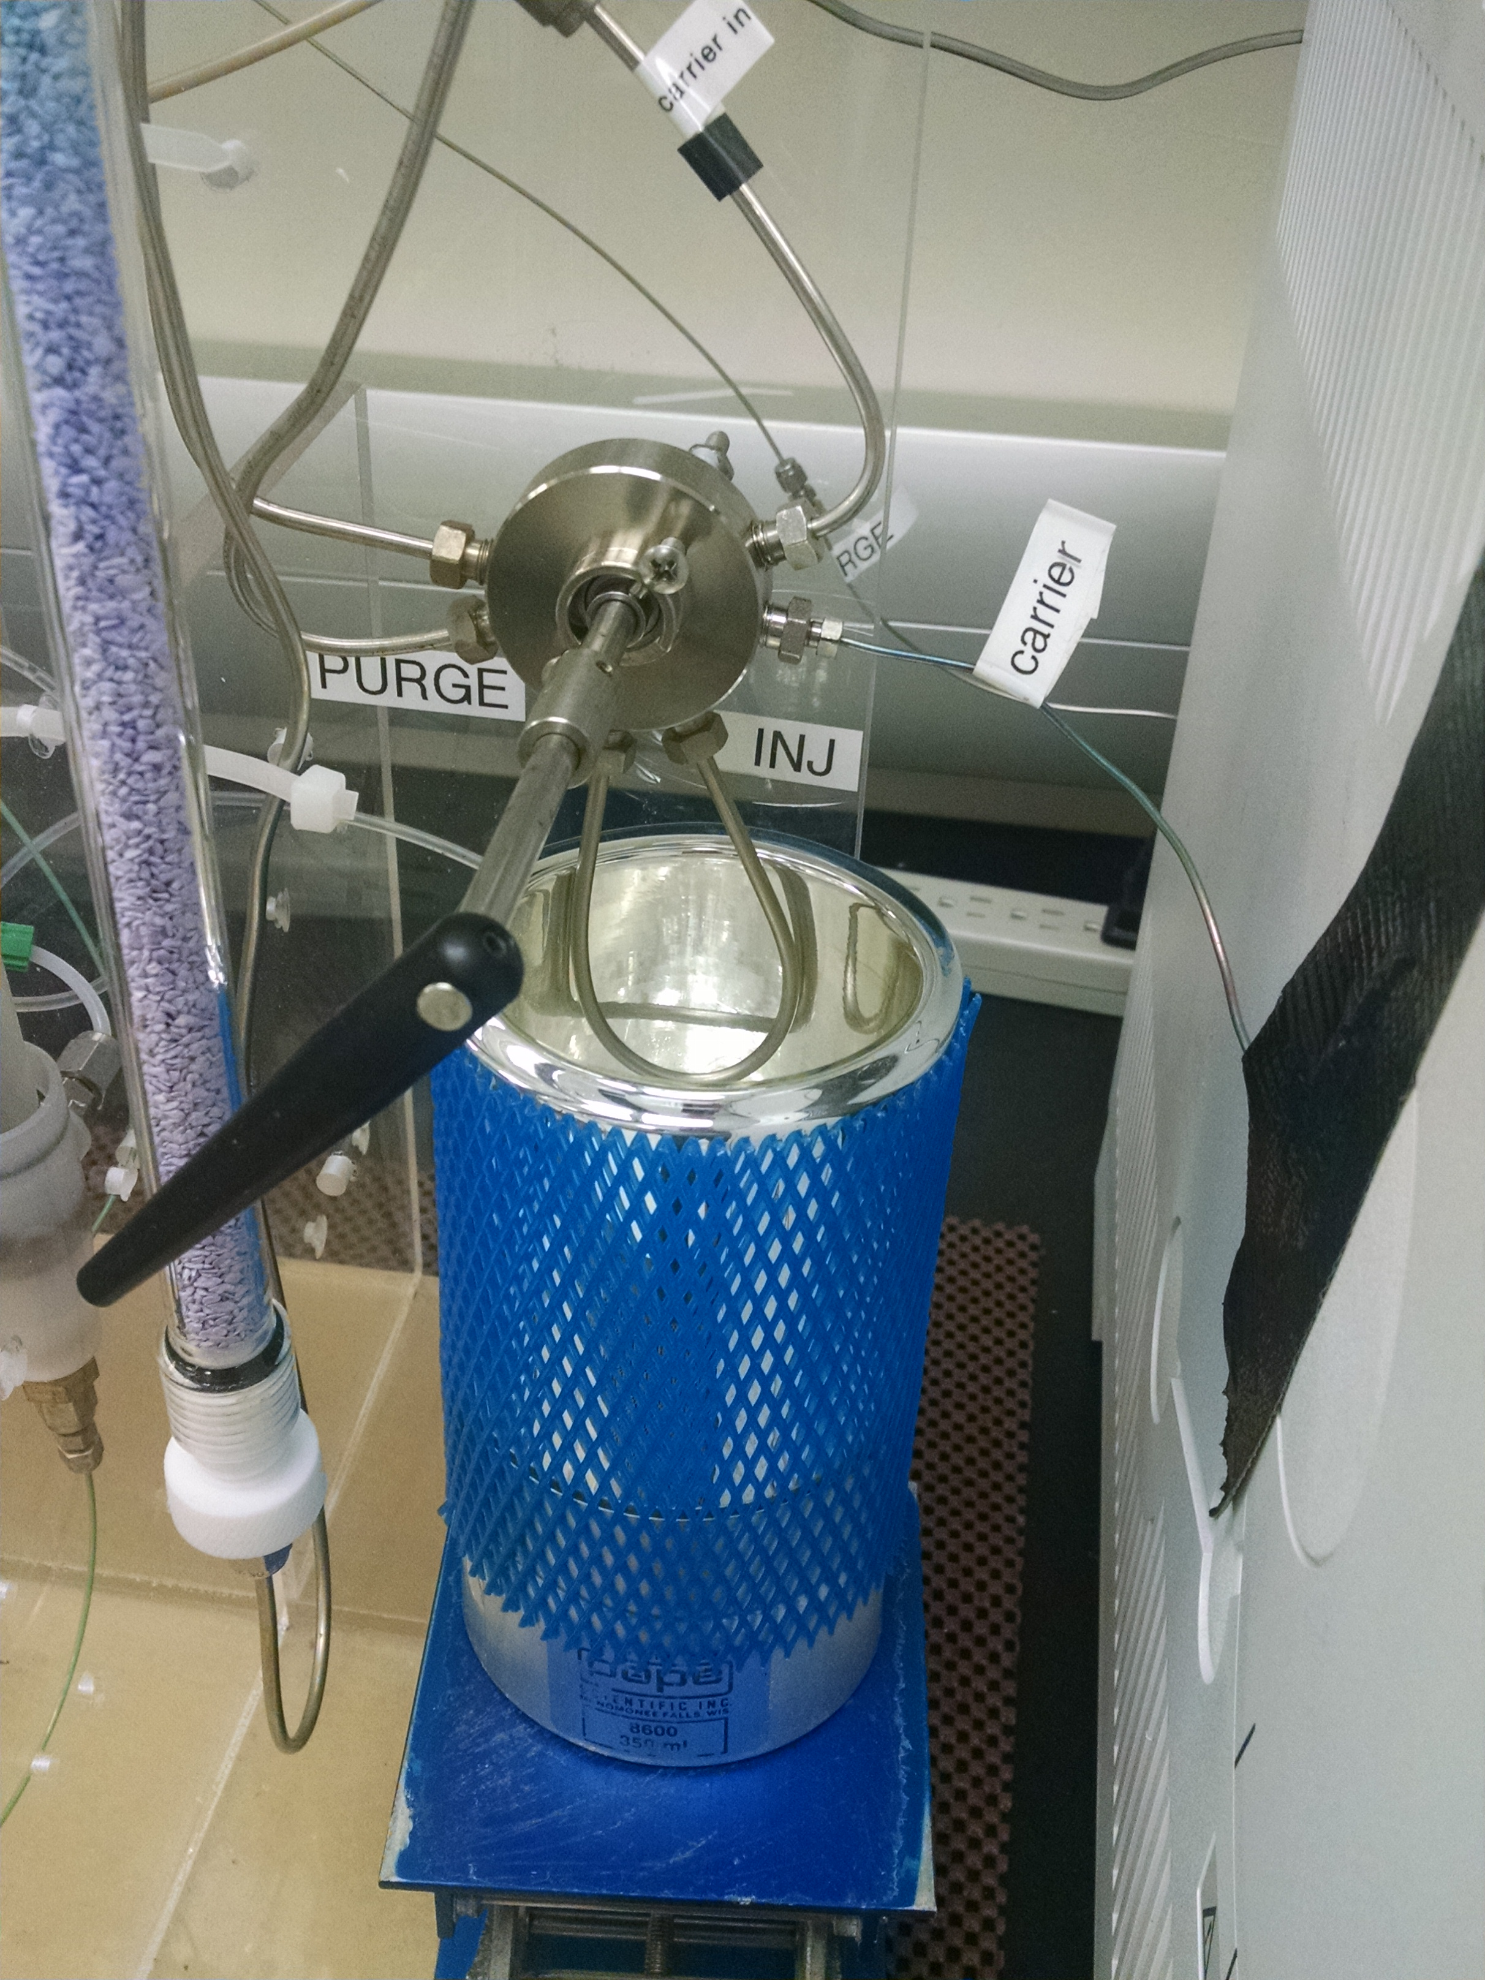

Figure 5. Packed sample loop as part of a 2-position 6-port switching valve (Valco: ). The loop is situated within a liquid nitrogen dewar flask which can be adjusted for height to keep the loop immersed in liquid nitrogen.

2.5 Quantification of gases
When the cryotapping valve is switched to the inject position, the packed loop is connected directly to the analytical column. Therefore the packed loop is flushed by the carrier gas which is usually helium or nitrogen. While it is relatively straightforward to connect the tubing to the column, the carrier gas might be sourced from the oven, the back of the instrument, or elsewhere. Either a packed (e.g. a 2 m HayeSep Q, 80/100 mesh , stainless steel column) or a capillary column (e.g 30 m x 0.32 mm GS-Carbon PLOT capillary column) can be used for separation and quantification. It is possible to analyze multiple gas species from the same sample, including both methane and nitrous oxide. This requires the GC to be equipped with a flame ionization detector (FID) and an electron capture detector (ECD) and the switch between detectors can be done manually or using commercially available technology such as a Dean’s switch (Wilson et al., 2017). Oven temperatures tend to be isothermal during the analytical run, a few degrees to tens of degrees above ambient lab temperatures (i.e. 35–50°C). The exact temperatures depend upon the peak separation associated with methane and nitrous oxide. It has been observed that at higher oven temperatures, O₂ can partially overlap with the methane peak necessitating in this instance a low (30°C) oven temperature . It is also customary to install a backflush or a ramped temperature program to prevent additional volatile constituents of seawater reaching the detectors. This is more important for the analysis of nitrous oxide when using an ECD.

2.6 Calculations
Calculation of the gas concentrations using the purge-and-trap method is achieved by application of the ideal gas law to the standard gas measurements:
PV = nRT
where P, R, and T are the same as Equation 1, V represents the volume of gas injected (L), and n represents amount of gas injected (typically in moles). Rearranging Equation 2 yields the amount of methane or nitrous oxide gas for each sample loop injection of compressed gas standards. These values were used to determine a calibration curve based on the measured peak areas of the injected standards, and thereafter derive the number of moles measured for each unknown sample. To calculate concentrations of methane or nitrous oxide in a water sample, the number of moles measured is divided by the volume (L) or mass of seawater sample analyzed. An example calculation is provided in the attached spreadsheet. Important to also measure laboratory temperature and correct for pressure too.

3.0 References
Bullister, J. L., and D. P.Wisegarver (2008), The shipboard analysis of trace levels of sulfur hexafluoride, chlorofluorocarbon-11 and chlorofluorocarbon-12 in seawater, Deep-Sea Res., 55, 1063–1074, doi: 10.1016/j.dsr.2008.03.014.
Capelle, D. W., Dacey, J. W., and Tortell, P. D.: An automated, high through-put method for accurate and precise measurements of dissolved nitrous oxide and methane concentrations in natural waters, Limnol. Oceanogr.: Methods, 13, 345–355, 2015.
Cline J. D., D. P. Wisegarver and K. Kelly-Hansen (1987) Nitrous oxide and vertical mixing in the equatorial Pacific during the 1982-1983 El Nino. Deep-Sea Research, 34,857-873.
Cohen Y. (1977) Shipboard measurement of dissolved nitrous oxide in seawater by electron capture gas chromatography. Analytical Chemistry, 49, 1238-1240.
Lilley M. D., J. A. Baross and L. I. Gordon (1983) Reduced gases and bacteria in hydrothermal fluids: the Galapagos Spreading Center and 2 1”N East Pacific Rise. In: Hydrothermal processes at seafloor spreading centres, P. A. Rona, K. Bostrum, L. Laubier and K. L. Smith, editors, Nato Conference Series IV: Marine Sciences, Plenum Press, New York, pp. 41 I-450.
Swinnerton, J. W., V. J. Linnenbom and C. H. Cheek (1962) Determination of dissolved gases in aqueous solutions by gas chromatography. Analyt. Chem., 34, 483-485.
Wilson, S. T., Ferrón, S., and Karl, D. M.: Interannual variability of methane and nitrous oxide in the North Pacific Subtropical Gyre, Geophys. Res. Lett., 44, doi: 10.1002/2017GL074458, 2017.
Zhang, G. L., Zhang, J., Kang, Y. B., and Liu, S. M.: Distributions and fluxes of methane in the East China Sea and the Yellow Sea in spring, J. Geophys. Res., 109, C07011, doi:10.1029/2004JC002268, 2004

