SOP3: Use of internal controls for methane and nitrous oxide analysis
Authors so far: Bonnie X. Chang¹, Stefan Otto², Gregor Rehder², Robert C. Upstill-Goddard³, Samuel T. Wilson⁴
¹University of Washington, Joint Institute for the Study of the Atmosphere and Ocean, Washington, USA
²Leibniz Institute for Baltic Sea Research Warnemünde, Rostock, Germany
³Newcastle University, School of Natural and Environmental Sciences, Newcastle upon Tyne, UK
⁴University of Hawai’i at Manoa, Daniel K. Inouye Center for Microbial Oceanography: Research and Education (C-MORE), Hawai’i, USA

1.0 Background to internal controls
Internal controls represent a self-assessment quality check to validate an analytical method. They provide additional information in support of the analysis of primary or secondary standards that are primarily used for instrument calibration (SOP2: Calibration of methane and nitrous oxide). When correctly used, internal controls help evaluate the accuracy of CH₄ and N₂O analyses and provide confidence in the consistency of the measurements. Such information is critical when comparing datasets produced by separate laboratories, however it has not always been included in the publication of CH₄ and N₂O measurements. One factor contributing to this is the lack of any recommended uniform approach to generating internal controls of the requisite quality and consistency. The internal controls described in this SOP are seawater samples in which the concentrations of dissolved CH₄ and N₂O are ‘known’. In practice, the concentrations of CH₄ and N₂O are not known, however, if the seawater salinity and the mole fractions of CH₄ and N₂O in ambient air are known, appropriate controls of temperature and of gaseous exchange enable a sufficiently ‘predicted’ concentration, hereafter referred to as ‘theoretical concentration’. The calculations that predicted CH₄ and N₂O concentrations are detailed in Section 3.0 and included in the spreadsheet accompanying these SOPs. Two methods are described below which produce internal controls with ranges in theoretical concentration of 2–3 nmol kg⁻¹ for CH₄ and 5–9 nmol kg⁻¹ for N₂O. These broadly represent the range of surface seawater concentrations close to atmospheric equilibrium. The use of internal controls can thus aid in determining analytical confidence when estimating the CH₄ and N₂O saturation state of the ocean, particularly when the surface seawater is within a few percent of saturation.

2.0 Production of internal controls
There are several approaches to producing internal controls, all of which rely on the equilibration of filtered seawater with an overlying headspace. The most commonly produced internal controls for CH4 and N2O typically equilibrate seawater with near-current atmospheric concentrations of CH4 and N2O, referred to as ‘air-equilibrated seawater’. At the most basic level, sub-sampling a beaker of seawater left to equilibrate for some time on the laboratory bench can provide a rudimentary estimate of analytical performance. Higher quality and more consistent values can be obtained with some degree of environmental control. Controlled environment production of air-equilibrated seawater is not limited to CH₄ and N₂O and has been used for other gases including oxygen and argon (e.g. Kana et al., 1994) and to determine gas solubilities (e.g. Hamme and Emmerson, 2004). This SOP describes two methods that provide air-equilibrated seawater for use as an internal control for CH₄ and N₂O. Prior to descriptions of both methods, sourcing of the air used in the equilibration process is briefly outlined.

2.1 Sourcing the air used for the equilibration process
The most common gas used in the equilibration process is air of modern-day composition. The principal consideration is whether to use compressed air (i.e. derived from a gas cylinder) or non-compressed air (i.e. derived from the ambient local atmosphere). Both approaches have advantages and disadvantages. Non-compressed air is easier to obtain on a research vessel, and any potential contamination can be minimized by sampling from the bow of the ship while it is underway. While the use of ambient air is deemed adequate for N₂O under most circumstances due to the homogenous atmospheric distribution of N₂O and its adherence to well-documented latitudinal gradients (Butler and Elkins, 1991), greater caution for CH₄ is prompted by potential local sources and microenvironments. The use of ambient air in high quality analysis demands regular measurements of its CH₄ and N₂O mole fractions and the continuous monitoring of atmospheric pressure. This is necessary because short-term changes in either of these will impact the equilibration process and consequently, the final concentrations of the internal controls. The alternative is to use compressed air, either obtained commercially or manufactured “in-house” using an air compressor and desiccant. The delivery of air from a compressed gas cylinder allows for a more controlled and consistent delivery than for ambient air.

2.2 Production of internal controls: Method 1
Method #1 for acquiring air-equilibrated seawater is that used by Dr. S. Wilson at The University of Hawaii. It is similar to that employed by the mass spectrometry community for analyzing O₂ and Argon (Kana et al., 1994). A 2 L Schott bottle is filled with 0.2 μm-filtered seawater to the 2 L mark and placed in a water bath maintained at a pre-determined temperature to within ± 0.1°C, during the equilibration step. The blade of an overhead stirrer (BDC250, Caframo) is inserted into the bottle and the rotation speed is optimized to ensure vigorous stirring without the entrainment of bubbles (Figure 1). A general rule of thumb is that the vortex created by the stirrer should not exceed 5 cm in height. The recommended duration of stirring is a minimum of 5 h so it is often most convenient to perform this operation overnight. The mole fractions of CH₄ and N₂O in the ambient air are measured using a GC-FID for CH₄ and a GC-ECD for N₂O (see SOP#4). Calibration is against a NOAA GMD gas standard (CB1098) with certified mole fractions of 1965.3 ppbv for CH₄ and 357.6 ppbv for N₂O. Following equilibration the overhead stirrer is removed, the equilibrated seawater is siphoned into crimp-sealed glass vials and analyzed as described for seawater samples.

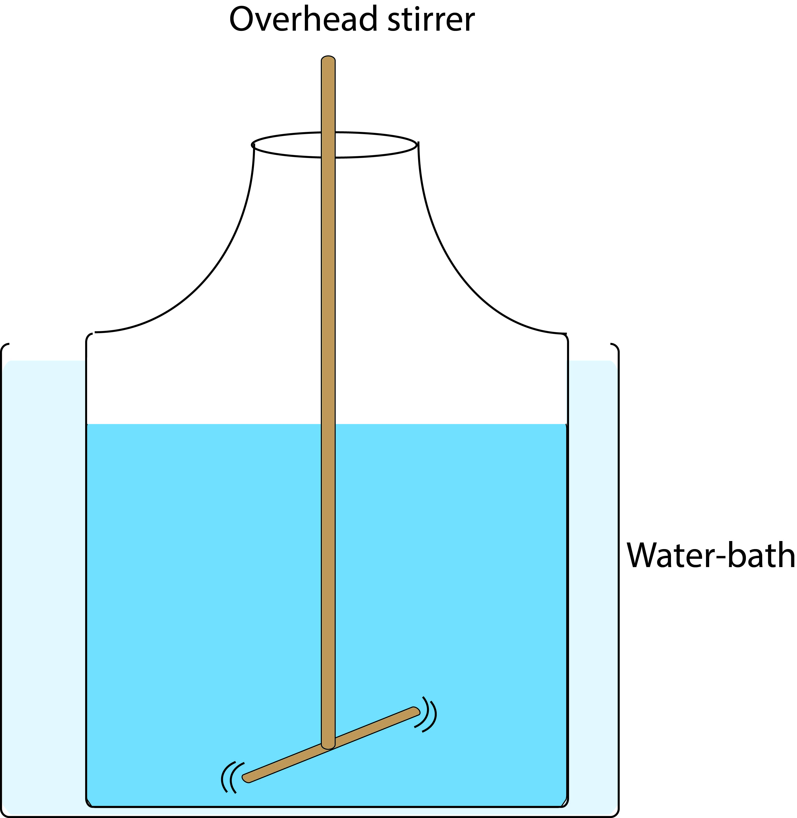
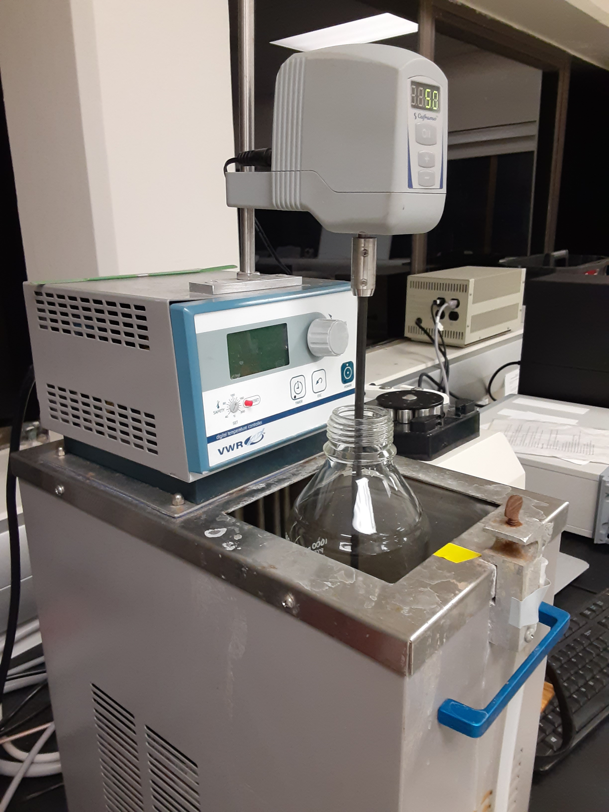
Figure 1. Production of air-equilibrated seawater for use as an internal control: (a), schematic of the bottle and stirrer; (b) the bottle and stirrer during overnight equilibration in a temperature controlled water bath.

Method ~1 is a straightforward way of creating batches of equilibrated seawater internal controls at different temperatures. The measured concentrations in these are then compared with predicted concentrations, as shown in Figure 2 for N₂O, where four equilibrated seawater batches were prepared at different temperatures in the range 18-27°C. The agreement between predicted and measured concentrations ranges from 0.1 to 3.8%. Figure 2 illustrates how internal controls aid in evaluating the robustness of the calibration process.
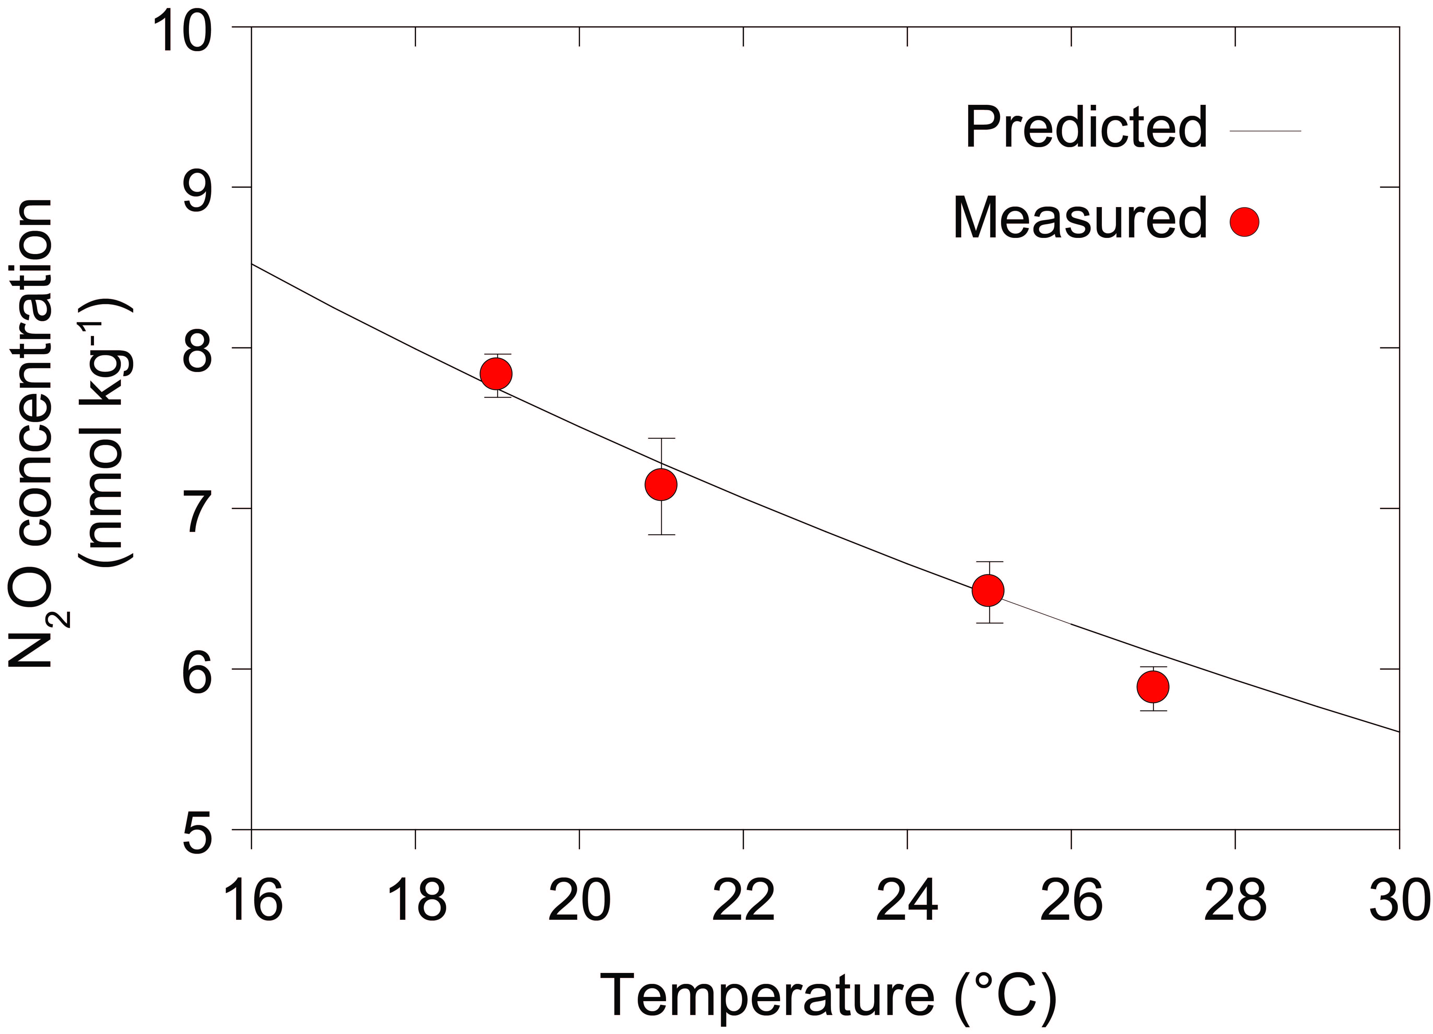
Figure 2. Seawater N₂O concentrations predicted (black line) and measured (red circles: air-equilibrated internal control samples at different temperatures) using Method #1. The equations used in predicting N₂O concentrations are presented in Section 3.0 and are included in the excel spreadsheet accompanying the SOPs.

2.3 Production of air-equilibrated seawater: Method 2
Method #2 has more sophisticated control conditions for the equilibrated seawater that provide for a higher level of certainty. It was initially developed for sulfur hexafluoride and chlorofluorocarbons (Bullister et al., 2002), and has since been used to create internal controls for N₂O. Using the procedures described below, seawater can be brought to within 0.1% of equilibrium, as determined for N₂O. The 0.2μm filtered seawater to be equilibrated is housed within a 4 L glass equilibration reservoir with a headspace:seawater volume ratio of 0.3 L:3.7 L. The glass chamber sits on a stir plate and both items are housed in a temperature controlled insulated box that maintains seawater temperatures to within ± 0.05°C (Figure 3). A magnetic stirrer keeps the water thoroughly mixed during equilibration. The equilibration air is typically sourced from a compressed gas cylinder and its flow rate to the equilibrator chamber is controlled using a needle valve. Upstream of the equilibrator chamber the equilibration air is bubbled through a small glass chamber containing distilled water to ensure it becomes saturated with water vapor at the appropriate equilibration temperature. The flow path of the moist gas is then split in to two: the first is plumbed through a bypass valve to the equilibrator headspace and the second is plumbed to a fritted tube extending to within approximately 3 cm of the bottom of the 4 L glass reservoir. When the bypass valve is closed, air flows only through the fritted tube and it bubbles the water in the reservoir. When the bypass valve is open, back pressure in the fritted tube ensures that all gas flow is to the equilibrator headspace. The air flow rate is set at 50 mL min⁻¹ for bubbling through the frit, and 25 mL min⁻¹ for purging the headspace. The glass chamber is vented to the outside of the box.
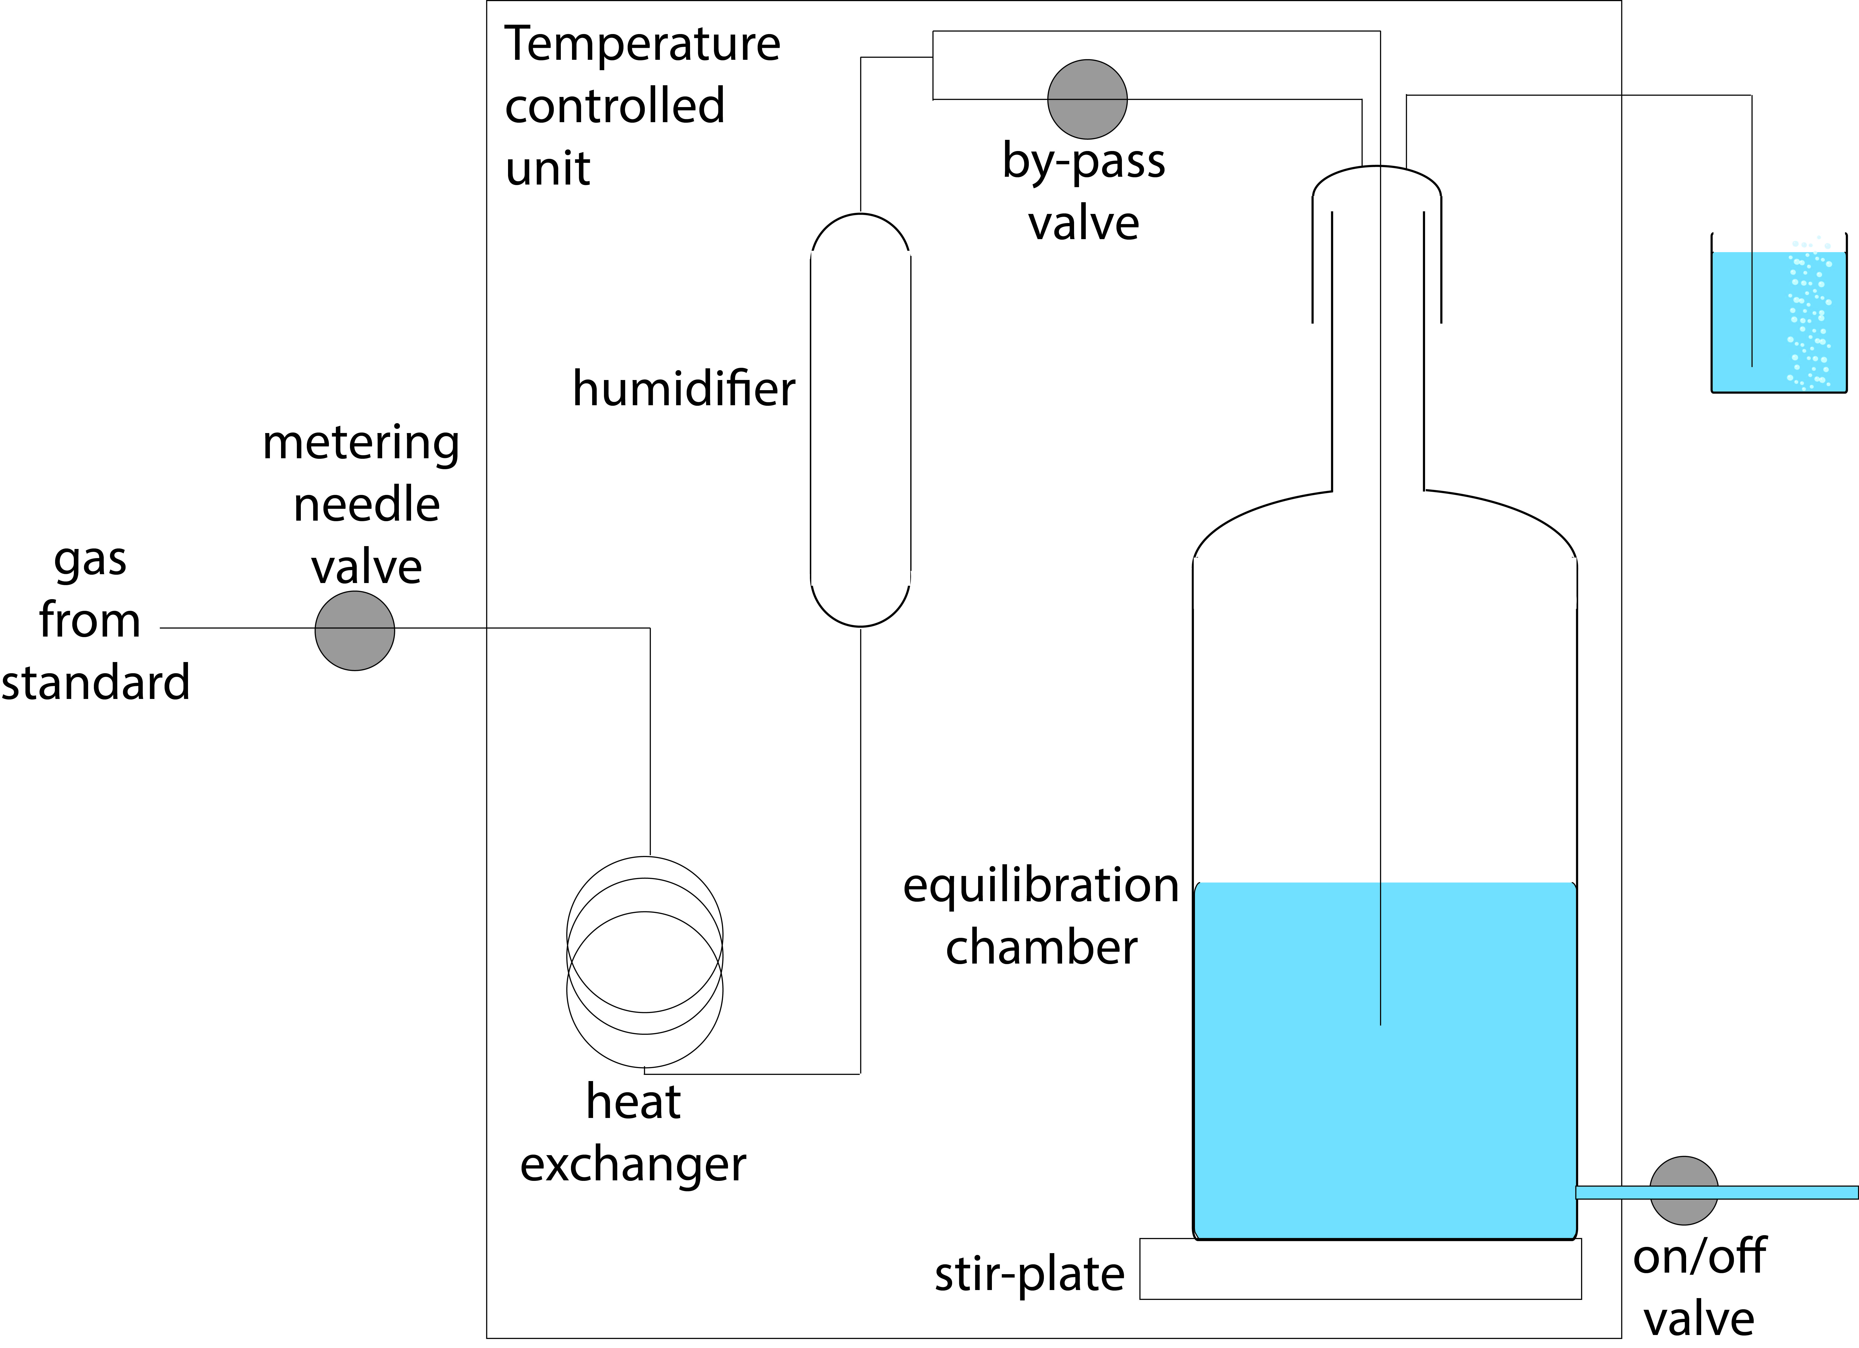
Figure 3. A schematic of the gas equilibration apparatus used in Method#2. Redrawn from Bullister et al. (2002).

The recommended equilibration procedure is to first bubble the seawater via the fritted tube to rapidly bring the dissolved gas content of the water close to air equilibrium. The bubble injection causes slight supersaturation of the solution relative to ambient air at atmospheric pressure. To ensure the equilibrated seawater pressure returns to ambient the bypass valve is opened and the headspace purged without bubbling and formation of bubbles in the stirring vortex. Because of the slow flow rate of air through the headspace and the absence of any signiﬁcant flow resistance through the vent tube, the headspace pressure during ﬁnal equilibration is only slightly above ambient atmospheric pressure. At the time of sampling, the stirrer is stopped, the rate of headspace purge is increased by a factor of two to preclude any entry of outside air during sampling, and the water samples are drawn from the equilibrator sampling port. To establish the optimum equilibration time a batch of equilibrated seawater is produced and the purge gas is switched to pure N₂. The rate of decrease in N₂O concentration is used to determine the equilibration half-times for both the bubbling (t_{b1/2}) and headspace purging procedures (t_{h1/2}) (Figure 4). Equilibration half-times for the headspace purging procedures (t_{h1/2}) can be a factor of 10 times longer than for bubbling (t_{b1/2}). The reservoir is bubbled for at least 10 times t_{b1/2} and the headspace is purged for at least 4 times t_{h1/2} prior to sampling.

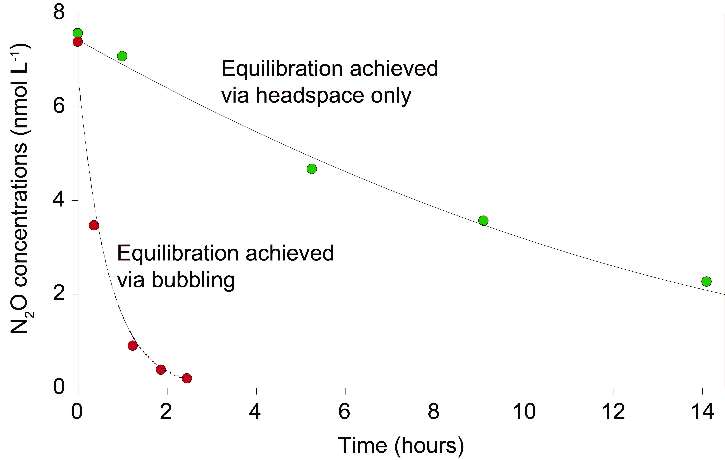

Figure 4. Comparison of N₂O equilibration times using two separate methods of seawater equilibration: bubbling (red symbols) and headspace mixing only (green symbols). The data were obtained using a 4 L equilibration chamber filled with 3.7 L of salinity 27.5 seawater air-equilibrated at 21.9°C. The bubbling rate was 70 mL min⁻¹ of pure N₂. Under these conditions, the equilibration half-time is 0.4 h for the bubbling method and 8.5 h for the headspace only method.

The daily analysis of seawater equilibrated onboard a research vessel using method #2 over a 24-day period is shown in Figure 5. Equilibrated seawater was analyzed at the start of each day and the measured concentrations were consistently within 1% of predicted concentrations.
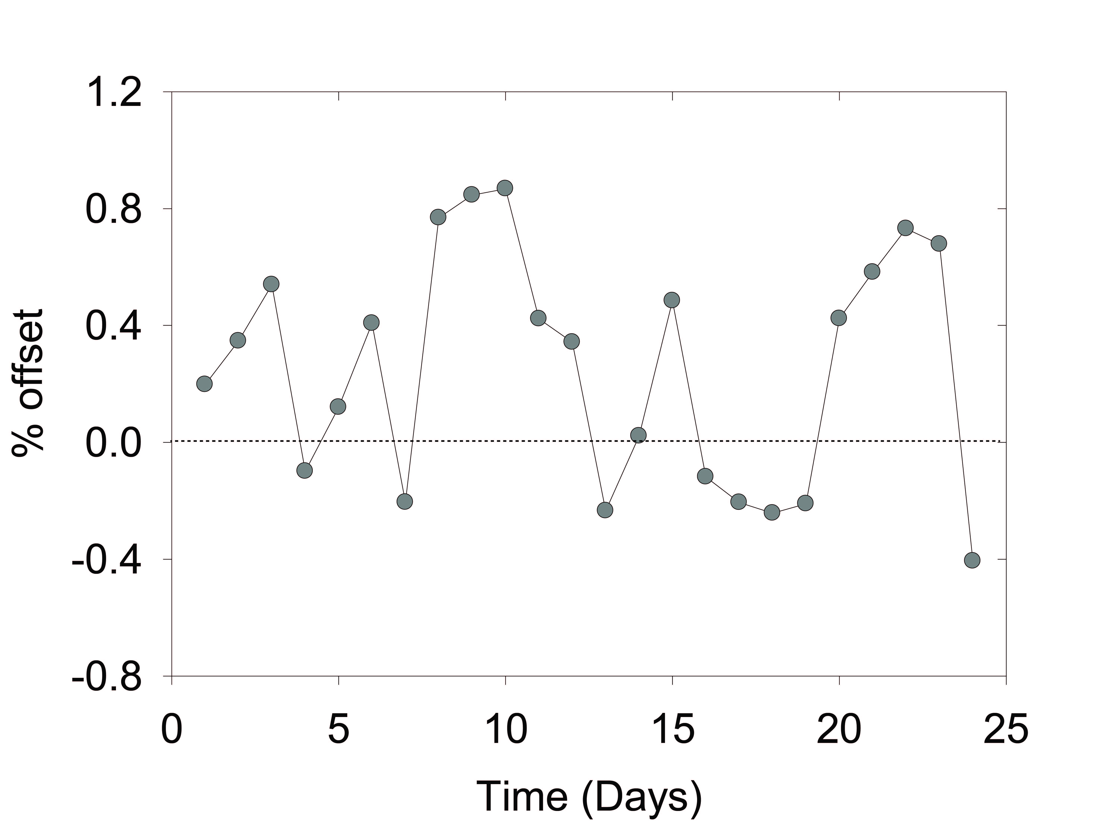
Figure 5. N₂O analysis in air-equilibrated seawater over a 24-day period. The equilibration conditions were: seawater temperature 20°C; salinity 36.8; atmospheric N₂O mole fraction 331.6 ppb. The values are reported as percent offsets between the predicted concentration and the daily measured values.

2.4 Production of internal controls with increased concentrations of CH₄ and N₂O.
The methods discussed so far in this Chapter highlight the production and analysis of internal controls that have dissolved CH₄ and N₂O concentrations in the low nanomolar range, close to equilibrium with modern-day atmospheric CH₄ and N₂O values. The ability to expand this and produce internal controls with elevated concentrations of CH₄ and N₂O concentrations will help evaluate the robustness of calibration curves at the upper end. This is something that is currently lacking as a common practice within the CH4 and N2O community For example, an intercomparison of CH4 and N2O relied on the collection of seawater samples from different depths of the water-column and separate locations to obtain samples with concentrations of xx CH4 and xx N2O (Wilson et al. 2018). This is not an ideal situation and while future intercomparisons are planned using consensus material generated in the laboratory, this will still involve storage and transportation of seawater samples which is not ideal (SOP#1). Therefore, the ability for laboratories to self-manufacture internal controls with elevated concentrations of CH4 and N2O is deemed critical to improve inter-comparability of CH4 and N2O analyses.
Internal controls with elevated CH₄ and N₂O concentrations cannot be achieved when equilibrating with the ambient atmosphere (i.e. Method #1 in Section 2.2) and requires the use of compressed gas cylinders (i.e. Method #2 in Section 2.3). This approach was recently demonstrated by Dr. Gregor Rehder at the Leibniz-Institute for Baltic Sea Research to provide internal controls with a theoretical concentration of 13.27 nM CH₄ and N₂O and 53.39 nM N₂O. A 5 L bottle containing filtered seawater was equilibrated with 9.257 ppmv CH₄ and 1991.92 ppbv N₂O (with air as the balance gas within the compressed gas cylinder). Final measured concentrations of 13.08 CH₄ (1% offset) and 52.38 N₂O (2% offset) were recorded.

Section 3.0 Calculations
The predicted concentrations of CH₄ and N₂O are obtained from Equations 1 and 2 respectively, which are included in the Matlab toolbox. Input parameters are atmospheric mole fractions (ppbv), the salinity and equilibration temperature (ºK), and relevant Bunsen solubility coefficients (Table 1). The values deriving from Equations 1 and 2 are in units of moles per liter and are subsequently corrected for density to derive moles per kg. The predicted air-equilibrated values for CH₄ and N₂O over a range of temperatures are given in Table 2.
For N₂O:
Equation 1a: lnC = log(AtmC*1e-9) + A1 + A2*(100/T) + A3*log(T/100) + A4*(T/100) + S*( B1 + B2*(T/100) + B3*((T/100)^2))
Equation 1b: conc = exp(lnC)
For CH₄:
Equation 2a: lnF = A1 + A2*(100/T) + A3*log(T/100) + A4*((T/100)^2) + S*(B1 + B2*(T/100) + B3*((T/100)^2))
Equation 2b: conc = exp(lnF)*AtmC

Table 1. Solubility constants used in Equations 1 and 2.
Solubility constant | Methane  (Wiesenburg and Guinasso, 1979) | Nitrous oxide  (Weiss and Price, 1980)
A1 | -415.2807 | -165.8806
A2 | 596.8104 | 222.8743
A3 | 379.2599 | 92.0792
A4 | -62.0757 | -1.48425
B1 | -0.059160 | -0.056235
B2 | 0.032174 | 0.031619
B3 | -0.0048198 | -0.0048472

Table 2. Predicted CH₄ and N₂O concentrations for a range of temperatures, at a salinity of 35.1 and for atmospheric mole fractions of 1890 ppbv for CH₄ and 330 ppbv for N₂O.
Temperature (°C) | Seawater density | Predicted  CH₄ (nmol kg⁻¹) | Predicted  N₂O (nmol kg⁻¹)
0 | 28.17 | 3.634 | 15.253
2 | 28.052 | 3.426 | 14.074
4 | 27.866 | 3.240 | 13.018
6 | 27.632 | 3.072 | 12.068
8 | 27.353 | 2.919 | 11.213
10 | 27.031 | 2.781 | 10.439
12 | 26.667 | 2.654 | 9.738
14 | 26.265 | 2.537 | 9.102
16 | 25.825 | 2.430 | 8.522
18 | 25.350 | 2.331 | 7.993
20 | 24.839 | 2.239 | 7.508
22 | 24.295 | 2.153 | 7.064
24 | 23.719 | 2.072 | 6.655
26 | 23.111 | 1.996 | 6.278
28 | 22.472 | 1.925 | 5.930
30 | 21.804 | 1857 | 5.608
32 | 21.106 | 1.793 | 5.309
34 | 20.381 | 1.732 | 5.031
36 | 19.629 | 1.673 | 4.772
38 | 18.850 | 1.616 | 4.531
40 | 18.047 | 1.562 | 4.305

Section 4.0 References
Bullister, J. L., Wisegarver, D. P., & Menzia, F. A. (2002). The solubility of sulfur hexafluoride in water and seawater. Deep Sea Research Part I: Oceanographic Research Papers, 49(1), 175-187.
Butler, J. H., & Elkins, J. W. (1991). An automated technique for the measurement of dissolved N2O in natural waters. Marine Chemistry, 34(1-2), 47-61.
Capelle, D. W., Dacey, J. W., and Tortell, P. D.: An automated, high through-put method for accurate and precise measurements of dissolved nitrous oxide and methane concentrations in natural waters, Limnol. Oceanogr.: Methods, 13, 345–355, 2015.
Hamme, R. C., and S. R. Emerson (2004), The solubility of neon, nitrogen and argon in distilled water and seawater, Deep Sea Res., Part I, 51, 1517–1528.
Kana, T. M., C. Darkangelo, M. Duane Hunt, J. B. Oldham, G. E. Bennett, and J. C. Cornwell (1994), Membrane inlet mass spectrometer for rapid high-precision determination of N2, O2, and Ar in environmental water samples, Anal. Chem., 66, 4166–4170.
Weiss, R. F., and Price, B. A.: Nitrous oxide solubility in water and seawater, Mar. Chem., 8, 347–359, doi: 10.1016/0304-4203(80)90024-9, 1980.
Wiesenburg, D. A., and Guinasso, N. L.: Equilibrium solubilities of methane, carbon monoxide and hydrogen in water and seawater, J. Chem. Eng. Data, 24, 354–360, doi: 10.1021/je60083a006, 1979.

