SOP2 Calibration of methane and nitrous oxide
Authors so far: Sam Wilson, Mercedes de la Paz, Bonnie Chang, Gregor Rehder

This SOP focuses on obtaining high-quality calibration values that are representative of the calibration gas and the analytical system. The separate parts to this process include calibration gases, delivery of the compressed gases, achieving a multi-point calibration, and fitting the appropriate calibration curve.

Section 1. Calibration gas standards
Calibration of the analytical instrumentation is nearly always conducted using standards consisting of compressed gases. Compressed gas standards of methane and nitrous oxide are typically produced in a blend of nitrogen or air. To the best of our knowledge, there is no evidence that either nitrogen or air represents a superior blend gas. Some laboratories favor nitrogen since there is no oxygen present, however in other instances it might be preferable to have oxygen included since it typically exists in the sample matrix. Compressed gas standards are typically sourced from commercial companies or national organizations. It is important that standards that have the highest possible accuracy. The standards with the highest accuracy can be obtained from National Agencies including National Oceanic and Atmospheric Administration Global Monitoring Division (NOAA GMD), the National Institute of Metrology China, and also the Central Analytical Laboratories of the European Integrated Carbon Observation System Research Infrastructure (ICOS-RI). The downside to National Agency standards is that their mole fractions are close to current day atmospheric values. The low mole fraction is not capable of calibrating high concentrations of methane and nitrous oxide, and therefore a standard with a higher mole fraction is also required. It is difficult to obtain highly accurate methane and nitrous oxide gas standards with mole fractions exceeding modern-day atmospheric values and this is particularly an issue for high concentrations of nitrous oxide. To address this issue, as part of the activity by SCOR Working Group 143, methane and nitrous oxide compressed gas standards were distributed in 2016 to twelve laboratories around the world. One of these standards had mole fractions closer to atmospheric concentrations while the other standard had 20 ppm nitrous oxide and 5 ppm methane.
Table 1. List of laboratories that received the SCOR gas standards of methane and nitrous oxide.
Institution | Lead Scientist
University of Hawai’i, USA | Samuel Wilson
GEOMAR, Germany | Hermann Bange
Newcastle University, UK | Robert Upstill-Goddard
Plymouth Marine Laboratory, UK | Andrew Rees
NOAA PMEL, USA | John Bullister
IIM-CSIC, Spain | Mercedes de la Paz
University of Concepción, Chile | Laura Farías
IOW, Germany | Gregor Rehder
University of California Santa Barbara, USA | Alyson Santoro
National Institute of Water and  Atmospheric Research, NZ | Cliff Law
University British Columbia, Canada | Philippe Tortell
Ocean University of China, China | Guiling Zhang

The SCOR standards and National Agency standards are considered primary gas standards. It is recommended that commercially purchased and home-made standards are cross-checked against these primary standards to ensure the accuracy of their contents. Cross-calibration of secondary standards for routine use will also prolong the lifetime of the primary standards to timescales of years. Recalibrations are recommended every 2-3 years for high precision work to build a drift history for the cylinder with a final calibration at the end of the cylinder's use when there is still at least 25 atm pressure left. When cross-calibrating standards, the mole fractions analyzed from each standard should be similar. This can achieved by varying the quantity of gas analyzed, e.g. injecting a small volume of a high concentration standard and a large volume of a low concentration standard.
Section 2. Delivery of gas standard via a two-stage pressure gas regulator
To deliver the standard gas from compressed gas cylinders to an analytical system, a two-stage pressure regulator is typically used with a length of copper or stainless steel tubing. When the cylinder valve is opened, the first gage of the regular displays the cylinder pressure and the second gage of the regulator displays the delivery pressure of the gas to the analytical system. The second-stage gage can be adjusted to achieve the desired value for the delivery pressure of the standard gas (typically less than 1 atm above ambient laboratory pressure). The actual flow rate to the analytical system is typically adjusted using a needle valve, and set to a measured value (e.g. 50 ml min⁻¹). When attaching a regulator to the cylinder, a regulator needs to be thoroughly flushed in order to remove ambient laboratory air and to allow only pure standard gas to be transferred to the analytical system. This will also prevent laboratory air from back-diffusing from the regulator into the cylinder, which could contaminate the contents of the cylinder. This contamination could happen if a regulator is attached to a cylinder and the cylinder valve opened with no flow out of the regulator.
A step-by-step guide to flush the 2-stage pressure regulator and provide pure standard to the analytical system is provided below. The text has been adapted from Bullister et al. (2017) which describes the production of the gas standards highlighted in Table 1.
1. Attach the regulator to the gas cylinder and tighten the compression fitting. If tubing leading from regulator vent to the analytical system is present, the tubing should be disconnected where it enters the sample loops of the analytical system. This will allow both the regulator and tubing to be flushed simultaneously.
2. Turn the regulator pressure knob (low pressure second-stage) clockwise enough turns so that when the first-stage of the regulator is pressurized, gas will immediately begin flowing out of the regulator and through the tubing.
3. Carefully open the cylinder valve a small amount to pressurize the first stage, and immediately close the cylinder valve. Gas should flow through the regulator's second-stage and tubing to vent. As gas is escaping, adjust the second-stage pressure to a value slightly above ambient to allow flow to continue through the tubing.
4. When the first-stage (high pressure) gage approaches zero, quickly reopen the cylinder valve a small amount again and allow the first-stage of the regulator to re-pressurize, and then immediately close the cylinder valve, and allow gas to escape as in step 3 above.
5. Repeat steps 3 and 4 five times, so the regulator and tubing is flushed a total of six times. During the last flush, as the first-stage pressure is approaching zero, open the cylinder valve fully, reconnect the tubing to the analytical system and adjust the second-stage pressure slowly to the desired value (typically a slight amount above ambient).
Note that if a standard regulator had remained attached to a standard cylinder for a prolonged period with low (or no) flow, it is possible that low levels of contaminants (from components inside the regulator, etc.) can slowly accumulate inside. When starting to analyze standards after a break of several hours or longer, it is probably useful to bleed off gas held in regulator by disconnecting the outlet tubing and flushing the regulator a few times as in steps 3-5 above.
6. When gas standards are not being run (and especially overnight or longer) the cylinder valve should be closed tightly and the second-stage regulator knob conpletely backed off (counterclockwise). This isolates the cylinder and keeps the regulator filled with standard, so that only 3 regulator flushes should be needed before a new set of samples are run.
7. To assure consistency, the flow rates of the standard gas to the sample loops should be controlled using an in-line needle valve, measured with a flow meter and adjusted to a fixed value (e.g. 50 ml min⁻¹). With all switching valves, the sample loop should be well-flushed prior to injection and it is at atmospheric pressure. This can be readily visualized by immersing the end of tubing is a small vial of water and checking for the presence of bubbles.
Section 3. Constructing a multi-point calibration curve
To achieve a multi-point calibration curve, varying volumes of a single gas standard can be injected into the gas analyzer or identical volumes of multiple gas standards with varying mole fractions can be injected. It is not uncommon that both techniques are used to construct a single calibration curve, particularly for nitrous oxide. In all cases, a 6-port or 10-port two-position switching valve is used to inject the standards. Such switching valves are often purchased from Valco Instruments as they provide reliable zero dead-volume valves. When setting up the switching valve, it is important to follow proper procedures for gas-tight fittings (see Valco Technical Note 105). Furthermore, the volume of the sample loop should also be calibrated and a full description of this procedure is provided in the Best Practice Guide for carbon dioxide, found in SOP11 ‘Gravimetric calibration of the volume of a gas loop using water ‘ (Dickson et al., 2007).
An important consideration when establishing an analytical system for CH4 and N2O is where to position the two-position switching valves. For the purge-and-trap method (SOP4), the two position valves, are typically situated prior to the sample handling system. This permits the entire analytical procedure, i.e. gas stripping and trapping, to be included in the calibration process (Figure 1). Furthermore, it is typical for the purge-and-trap method to include multiple (2-3) two-position valves which facilitates a multi-point calibration curve.
Figure 1. Location of multiple two position, 6-port switching valves at the head of the analytical pipeline as typically used in the purge-and-trap analysis (see SOP4). Each of the three valves is fitted with a sample loop of varying size to facilitate a multi-point calibration curve

For the headspace method (SOP5), the two-position valve is situated at the head of the analytical column. This is a typical location when conducting gas chromatography which uses on-column injection. The switching valve and sample loops are set on a temperature controlled heating block and injection is either activated manually or as part of a run sequence program. Such a set-up is limited to a single valve and therefore a 10-port switching valve is typically used with two sample loops of varying size (Figure 3). The two sample loop provides a more limited range of calibration points compared to the purge-and-trap. The other limitation is that the calibration process does not include the gas equilibration and injection processes, although this can be achieved by the analysis of internal controls (SOP3).
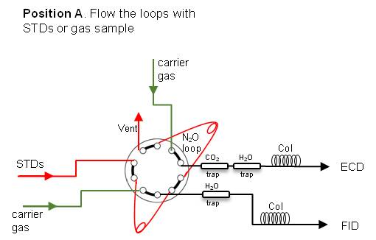

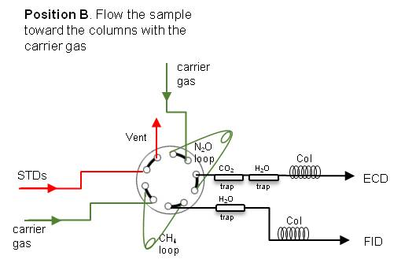
Figure 2. An example configuration of a 10-port, 2-position switching valve. Two sample loops of varying volumes are installed allowing for the injection of the calibration gas onto two columns.
Section 4. Fitting a calibration curve for methane via GC-FID
The FID has a linear response to methane at nanomolar concentrations and therefore, a linear fit to the calibration values is appropriate. It is important that calibration values span the range of the data values. It is also important that the whole equation (signal = slope * concentration plus intercept) is used and that the intercept is not forced through zero or ignored. The intercept should be very close to zero as methane analysis via GC-FID should not have a sizable blank. If a sizable positive or negative intercept exists, then it indicates an analytical or calibration issue.
Comparison of three plots of methane calibration values highlights how errors can be introduced during the calibration fit (Figure 4). The plots show low variation in the slope value when calibration points are increased from low mole fractions (Fig. 4a) to higher mole fractions (Fig. 4b). However, the intercept value is sensitive to the range of calibration values used, and this effect is exacerbated when only the higher calibration points are included (i.e. Fig. 4c). In this instance, an almost 30% increase in final methane concentration occurs from the use of the calibration equation in Figure 4c, compared to Figure 4a (show calculation below). This highlights the importance of using the whole calibration equation and paying attention to both the slope and the intercept value.
Figure 3. Calibration of the FID for methane
Section 5. Fitting a calibration curve for nitrous oxide on a GC-ECD
Calibration of the ECD is not as straightforward as the FID. The range of dissolved nitrous oxide concentrations nearly always extends beyond any linear part of the ECD response. An exception to this would be for analyzing a narrow range of concentrations, such as the sea-air interface. Overall, a quadratic fit to the calibration data points is an appropriate calibration curve to use (Figure 5). However, there may be instances where a single quadratic fit is deemed insufficient. This typically becomes evident to the analyst when a single fit causes the final concentration of low or high samples to deviate significantly from the known or expected concentration (see SOP3 ‘internal controls’). In this instance, it may be preferable to use two separate quadratic fits; one for low nitrous oxide concentrations and one for high nitrous oxide concentrations.
Some laboratories use a multi-linear (or ‘stepwise linear’) fit instead of a quadratic fit. A multi-linear fit might be used when using direct column injection due to the limited number of data points that can be generated. As mentioned previously, with two standards of varying concentration and two loops of varying volumes, four data points are produced, which is insufficient to apply a robust quadratic fit.
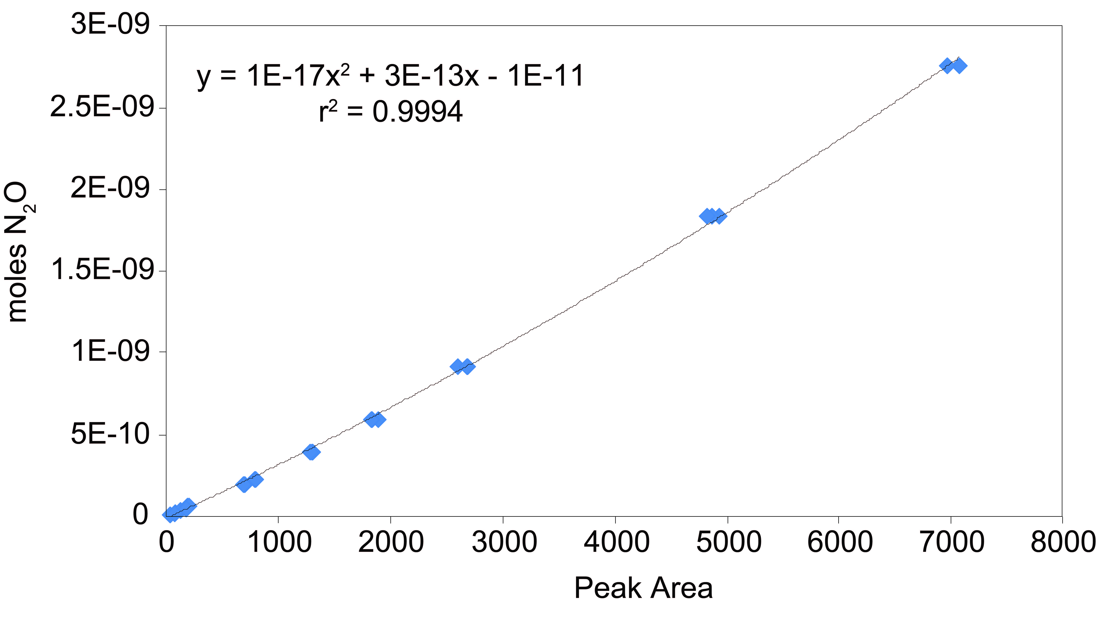
Fig 4: Calibration of the ECD for N2O.
In addition to constructing a calibration curve, some additional analysis of the ECD nonlinearity can be useful. This knowledge helps identify the detectors response relevant to the range of sample concentrations being analyzed, the behavior of different ECDs, changes in nonlinearity with time, and cross-calibration of standards. However, there is not a lot of information available in the scientific or technical literature about how such an assessment can be performed. The majority of CH4 and N2O analyses measure and calibrate against peak area from standards of known concentrations. Peak area is a much more common chromatogram property to record rather than peak height because it is less sensitive to the effect of peak broadening, although peak height is a simpler measurement and is less prone to interference by neighboring peaks,. Peak broadening occurs when the molecules of the target compound pass along the analytical column. If a peak broadens, the peak area remains proportional to the total quantity of substance passing into the detector, which the peak height will be lower and the width will be greater. Comparison of peak height versus the peak area can be used to evaluate the non-linearity of a detector. An alternative method, relying solely on the peak area property is provided below. This method of assessment uses the peak area obtained from the analysis of a primary standard to predict the peak area for a subsequent standard injection (Equation 1). Calculating the difference between the predicted peak area and the measured peak area provides a quick assessment of the linearity (Equation 2).
$$Equation 1= \frac{Peak area std_1}{Peak area std_x}{*mole fraction of std_1}_{}$$
$$Equation 2= \frac{Value from Equation1}{mole fraction of std_x}$$
Table 2. Example dataset for nitrous oxide
Parameter | Standard 1 | Standard 2 | Standard 3 | Standard 4
mole fraction analyzed | 0.02 | 0.05 | 0.199 | 0.397
Peak area | 89.1 | 190.9 | 713.8 | 1310.5
Equation 1 | 0.02 | 0.04 | 0.16 | 0.29
Equation 2 | 1.00 | 0.86 | 0.80 | 0.74
Offset (%) | 0 | 14.3 | 19.9 | 26.5

Table 3. Example dataset for methane
Parameter | Standard 1 | Standard 2 | Standard 3 | Standard 4
mole fraction analyzed | 0.080 | 0.375 | 1.665 | 2.497
Peak area | 89.1 | 125.86 | 546.71 | 821.94
Equation 1 | 0.08 | 0.38 | 1.67 | 2.51
Equation 2 | 1.0 | 1.02 | 1.00 | 1.01
Offset (%) | 0 | 2.4 | 0.2 | 0.5

Comparison of the relative difference highlights the nonlinearity of the ECD is greatest at the lowest concentrations.
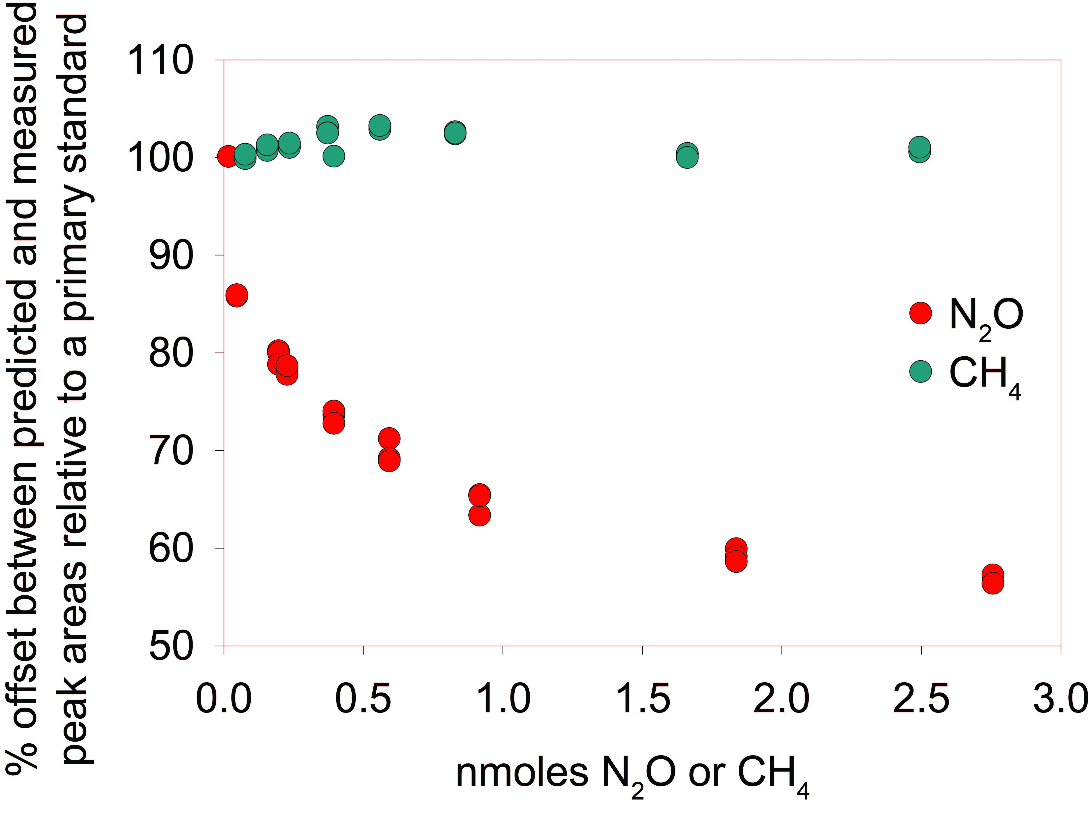
Figure 5. Comparison of the ECD and FID responses to highlight the nonlinearity of the ECD.

Would be good to include some text about the need to monitor the drift of the detector.

