SOP1: Sampling and sample storage
Authors so far: Sam Wilson, Bonnie Chang, Brett Thornton, John Pohlman, Gregor Rehder

Collecting and storing samples without compromising their integrity is a critical first step in the analytical process. Handling seawater samples intended for CH₄ and N₂O analysis is particularly challenging because large differences can exist between the environment sampled and the atmosphere. The inadvertent exchange of these invisible and relatively insoluble gases between the sample and surrounding air at any time prior to analysis in the laboratory can lead to significant biases that may not be accounted for during instrument standardization. Therefore, the methods used for sample collection must be thoughtfully adapted for each environment and accommodate logistical constraints such as water availability, manpower, and time. Most seawater samples are collected from hydrographic Niskin bottles that allow for drainage into a glass bottle or syringe via a spigot. Therefore, this SOP discusses relevant considerations for conducting bottle-based sampling followed by a discussion of sampling into syringes.

Section 1. Sampling using glass bottles
Sample bottle: The key consideration when selecting a sample bottle is to ensure that it is inert and gas-tight to the extent possible, with respect to methane and/or nitrous oxide. A variety of bottles meet these requirements and it is worth quickly highlighting their potential use before discussing the most commonly preferred bottle. For example, glass-stoppered bottles, as used for dissolved oxygen or Dissolved Inorganic Carbon (DIC), are inert, gas-tight, and do not need the equipment required for crimp-sealed bottles. Overall, glass-stoppered bottles are not recommended because they do not facilitate analysis without exposure to ambient air. Furthermore, it is not recommended to use grease because this can introduce additional organic material to the sample and this limits their use to short sample storage only.

Therefore, the majority of sampling for methane and nitrous oxide uses borosilicate glass vials with an opening that is closed by a rubber stopper and a 20 mm aluminum crimp-seal. Bottle sizes range from 20 ml to 500 ml (Photo 1). While only tens of milliliters of seawater are required to quantify dissolved methane and nitrous oxide at low nanomolar concentrations, it is recommended to use 160 ml to 200 ml bottles of a larger size to mitigate the influence of any tiny bubbles of contaminant air introduced during sampling or the effect of temperature fluctuations during storage.
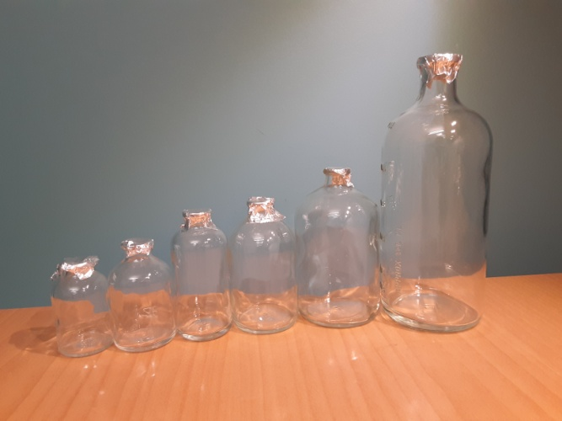

Photo 1 Different sizes of glass vials which can be capped. The calibrated volumes of each bottle are taped onto the front. They differ from the volume of the bottle reported by the vendor who cite the volume up to, but not including, the neck of the bottle.

The sample bottles should be thoroughly cleaned between each use. The cleaning procedure needs to remove organic material and attached microorganisms. Furthermore, a thorough clean will also mitigate bubbles from sticking to the side of the bottle when the sample is collected (Liger-Belair et al., 2013) and also remove any trace quantities of preservative that was added. Cleaning procedures differ between laboratories but generally involve cleaning with hydrochloric acid (10% vol/vol) followed by a thorough rinsing with MilliQ water. If the sample bottle is particularly dirty, then a prior wash with a dilute detergent might be useful. After washing, the sample bottles are placed in a drying oven (e.g. 120°C for 5 h) prior to storage. Alternatively, the sample bottle can also be combusted (e.g. 450°C for 5 h) with aluminum foil covering the open top.

Stoppers: When using bottles that are closed with rubber stoppers, it is critical to select a stopper that has minimal or zero effect on the dissolved gas to be analyzed (Photo 2). These considerations appear to be more critical for methane rather than nitrous oxide, due to the potential release of methane and other hydrocarbons from the septa (Niemann et al., 2015). This is particularly relevant for samples with low concentrations of methane as the addition of contaminant methane will be more evident (Magen et al., 2014). There has been some practice within the community to try and decrease the release of hydrocarbons from stoppers by boiling them in sodium hydroxide or hydrochloric acid. Such ‘cleaning steps’ were not observed to have any effect over an 8 day period (Magen et al., 2014). In addition to the leakage of gases from the septa, sample gases can also adsorb onto the septa and therefore decrease concentration. Ultimately, the potential of stoppers to affect the integrity of the sample is one of the contributing reasons why storage of samples can be problematic.

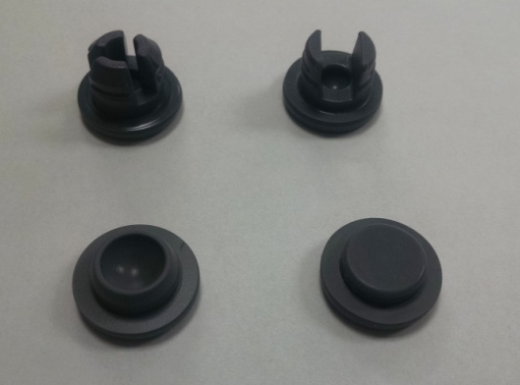
Photo 2. Stoppers vary in material composition, size, and shape. The photo on the left shows four types of butyl rubber stoppers. Our preferred type are the flat teflon-lined stoppers (bottom right) or the two-legged type (top right). The preference is based on the ability to seal with no bubble trapped underneath.

Sampling: Most gas samples are collected using a sampling bottle attached to a rosette such as a Niskin bottle (Photo 1.3). Some of the UNOLS and NOAA fleet carry Niskin-bottles which have been modified to improve their effectiveness for trace gas sampling. These modifications include modified end-cap to minimize the contact of the water sample with the endcap o-rings after closing and stainless steel springs covered with a nylon powder coat to close and hold the end-caps in position (Bullister and Wisegarver, 2008). Once the rosette of bottles is retrieved from the water and secured, sampling should occur promptly afterwards. Once the top valve of the Niskin bottle has been opened, the entry of atmospheric air will start to exchange with the seawater sample. Therefore, to avoid sampling contaminated seawater, the final one-third of the bottle’s contents should not be sampled for dissolved gases. The tubing using to dispense the seawater needs to accommodate the spigot of the sampler and fit through the neck of the sample bottle. To facilitate this range of sizes, tapered, or bubble tubing, with different tubing diameters at each end can be used or two different sizes of tubing with a connecting device. The tubing and container should be flushed with seawater sample volume 2-3 times that of the container and tubing volume, if there is sufficient sample material available.

Sample Storage: No matter how a sample is stored, its internal concentration will change over time. To eliminate the storage effect, the sample can be analyzed within a few hours of collection. If that is not possible, the samples should be stored in a refrigerator at 4°C in the dark to reduce the exchange of gas with the septa. If samples are to be stored at room temperature, expansion of fluids during warming may displace the septa within 3-5 hrs of collection. In that case, the septa should be replaced or pierced with a hypodermic needle to relieve pressure. Once punctured a silicone sealant should be applied.
One commonly asked question is how long can samples be stored for? This question is impossible to answer as it depends on a number of variables including the origin of the samples, storage conditions, any transportation of the samples, and the sampling procedures that were used. It is informally considered that storage times should not exceed several months, however even this duration might not be feasible.
To illustrate the impact of sample storage on CH4 concentrations, seawater samples were collected over a 2 year period from two depths (600 and 800 m) in the North Pacific Subtropical Gyre (22.75°N, 158°W) (Wilson et al., 2017). Upon collection into a 240 ml crimp-sealed bottle, the samples were preserved using mercuric chloride, and stored in the dark at room temperature until analysis. Sampling environmentally low CH4 concentrations was intended to facilitate any observed increase in concentrations. The samples were collectively analyzed and both sets of samples showed an increase in CH4 concentration over time, with a stronger relationship observed for the samples collected from 800 m (Figure 1). It is not known whether the increase in CH₄ was due to intrusion of gas from the ambient environment or leakage of CH₄ from the septum, but it is noteworthy that it began immediately after storage indicating that any storage time has an effect. The dataset does not provide an insight for supersaturated CH4 samples which might be impacted by loss of CH4 due to release from the bottle or release of CH4 from the septum.
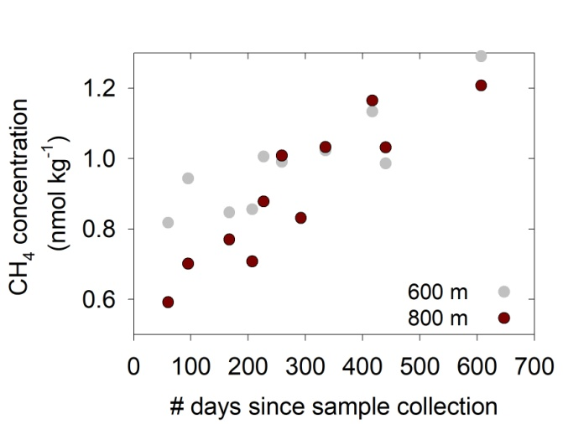
Figure 1. Effect of storage time on CH₄ concentrations for undersaturated seawater samples. The samples were collected from two deep water depth horizons in the open ocean which are considered to have very low variability. Storage times for almost two years and the samples were analyzed simultaneously on the same day.

Preservative: When storing a dissolved gas sample for a period of time extending beyond a few hours, a preservative must be added to eliminate biological activity. The choice of preservative is not without contention and there is an increasing list of preservatives being used by the scientific community (e.g. Magen et al., 2014, Bussmann et al., 2015). These include sodium azide, sodium hydroxide, sulfuric acid, potassium hydroxide, benzalkonium chloride, and zinc chloride. However pending a community-wide evaluation of their effectiveness over a range of microbial assemblages and environmental conditions for both methane and nitrous oxide, it is not evident that they are a superior alternative to mercuric chloride. Mercuric chloride has a long history of usage as the preservative for not only dissolved methane and nitrous oxide, but also DIC. The recommended dosage, based on direct observations of microbial activity (Dickson, 2010), is 100 μl of saturated solution per 100 ml of seawater sample.
There is an important caveat to the use of mercuric chloride when measuring nitrous oxide in samples with high nitrite and iron concentrations. Abiotic nitrous oxide production is stimulated by the addition of mercuric chloride and zinc chloride in the presence of nitrite and iron (Ostrom et al., 2016). These conditions can occur with samples spiked with 15N-nitrite to determine rates of nitrous oxide production (Bourbonnais et al., 2021).

Section 2. Syringe sampling as an alternative to glass bottles
Collecting samples with a gas-tight syringe is advantageous because it permits sampling without the use of tubing, allows for storage without using toxic preservatives, and eliminates exposure to the ambient atmosphere, which may be important when dissolved CH₄ and N₂O concentrations are highly sub-saturated or super-saturated or when one performs sample analysis in the field. Syringe volumes used to collect samples range from 60 ml (Crill et al.,1991), to 250 ml (Bullister et al., 2002) to 1 L (Pohlman et al., 2021). The syringe is connected directly to the spigot of the sampling bottle using a 3-way plastic stopcock, which facilitates flushing the syringe, or with tapered tubing. The syringe is rinsed several times by partially filling with seawater and then expelling the water from the syringe, before a final filling. Care is taken to exclude any bubbles during this procedure. The dissolved CH₄ and N₂O from samples collected with syringes is immediately extracted by purge-and-trap or headspace equilibrium, followed by analysis in the field or storage in the gas phase without toxic preservatives. Two examples are provided below where the sampling involves syringes.

(1) The purge-and-trap method developed for SF6 and CFCs (Bullister et al., 2008) was subsequently extended to include N2O. For this method, 250 ml glass syringes are filled from the collection bottle and immersed in a cold (0°C) water bath. The cold-water bath minimizes the formation of bubbles and thereby prevents supersaturation of the dissolved gases in the seawater in the syringes due to warming during storage. Prior to analysis, each syringe is transferred to a warm (25°C) water bath for30–40 min to allow the seawater sample to warm to this constant temperature. This solubility is decreased and purging efficiency increased for these dissolved gases at this higher temperature, allowing more rapid and efficient purging of the gases from the water sample into the cold trap. Although this temperature increase can cause the dissolved nitrogen in some seawater samples to become supersaturated, the kinetics of bubble formation in seawater held in the syringes is slow enough that no bubbles are typically observed to form during this brief warming period. To initiate the analysis of a seawater sample, the syringe valve is connected to the side arm of a glass purge chamber (see SOP#4), the syringe valve manually opened, and a subsample of seawater injected.

(2) Syringe sampling followed by headspace equilibrium is performed by the addition of CH₄ and N₂O-free gas into the syringe at a prescribed water to headspace ratio that ranges from 4:1 to 9:1, depending on the application (Crill et al., 1988; Pohlman et al., submitted). Higher headspace ratios concentrate the CH₄ and N₂O into a relatively smaller headspace (Magen et al., 2014), which is advantageous for analyzing lower concentrations or obtaining sufficient gas for stable isotope analysis (e.g., Leonte et al., 2017; Pohlman et al., 2021). Typically, nitrogen is used as the headspace gas (Crill et al., 1998; Kelly and Jeffrey, 2002), however, synthetic air and other gases may be used when analyzing gases by laser absorption spectroscopy (Rella et al., 2013). After the addition of the headspace gas, the syringe is shaken to achieve equilibrium between the gaseous and liquid phases (see SOP#5?). The gas may then be removed by separate syringe for immediate analysis (Pohlman et al., 2021) or transferred by displacement into a glass vial containing saturated sterile brine solution and stored upside down and in the dark. Storage of equilibrated gases avoids the need for preservative which can be ineffective for samples with high organic loading or prohibited by certain institutes or research vessels. Stored samples are subsequently analyzed upon return to the laboratory by displacement of the headspace into a sample loop housed in a multi-position switching valve. To the best of our knowledge, however, storage by this method has not been compared against other headspace equilibration procedures.

Section 3 Step-by-step guide for sampling using glass bottles
Equipment needed
borosilicate glass vials, drawing tube, aluminum crimp seal vials, rubber stoppers, crimper, MgCl2
syringe/needle, gloves

Method:
Before starting
1. Prepare a saturated solution of mercuric chloride (HgCl₂) in advance. Always ensure good lab practices when working with mercuric chloride and read the MSDS. The saturation of mercuric chloride is 7.4 grams per 100 mL of water. The solution should always stay saturated and therefore crystals should always be observed in the bottom of the bottle.
2. Label your sampling bottle. Typical sample labeling is Cruise ID-Station-Cast-Bottle e.g. 1417-1-1-3 represents cruise-station-cast-niskin bottle. Anecdotal information can also be included on the label.

3. Some good practice when sampling around a rosette is to keep the sampling bottles in a small cooler as this keeps them cool, dark, and acts as a container in case of breakages. Having a separate area for adding the preservative away from the sampling area is recommended.

Sampling
1. Fill the glass vials from the niskin bottles. Rinse twice and fill to 3 x overflowing. It is important to ensure there are no bubbles in the drawing tube, so continually pinch the drawing tube when filling the glass vials.

2. Take sample bottles to the safe preservative place. Add 100 μl mercuric chloride to each vial using the syringe/needle. Ensure that the needle tip is beneath the neck of the vial.

3. A useful technique to avoid creating a bubble of air when adding the rubber stopper is to pierce the stopper with a hyperdermic needle (22 gauge) prior to adding the stopper. The tip of the needle should not extend beyond the inner surface of the stopper by more than 1 mm (and flush with the surface is fine). When the stopper is pressed into place, any trapped air is ejected through the needle.

References
Bullister, J. L., and Wisegarver, D. P. 2008. The shipboard analysis of trace levels of sulfur hexafluoride, chlorofluorocarbon-11 and chlorofluorocarbon-12 in seawater, Deep-Sea Res., 55, 1063–1074.
Crill, P. M., Bartlett, K. B., Harriss, R. C., Gorham, E., Verry, E. S., Sebacher, D. I., Madzar, L. and Sanner, W. 1988. Methane flux from Minnesota peatlands. Global Biogeochemical Cycles, 2, 71-384.
Dickson, A.G., 2010. Standards for ocean measurements. Oceanography, 23, 34-47.
Dickson, A.G., Sabine, C.L. and Christian, J.R. (Eds.) 2007. Guide to Best Practices for Ocean CO2 Measurements. PICES Special Publication 3, 191 pp.
Kelley, C.A. and Jeffrey, W.H., 2002. Dissolved methane concentration profiles and air‐sea fluxes from 41 S to 27 N. Global Biogeochemical Cycles, 16, 13-1.
Leonte, M., Kessler, J. D., Kellermann, M. Y., Arrington, E. C., Valentine, D. L., and Sylva, S. P. 2017. Rapid rates of aerobic methane oxidation at the feather edge of gas hydrate stability in the waters of Hudson Canyon, US Atlantic Margin, Geochim. Cosmochim. Acta, 204, 375–387.
Liger-Belair, Gérard. Uncorked: The Science of Champagne-Revised Edition. Princeton University Press, 2013.
Magen, C., Lapham, L. L., Pohlman, J. W., Marshall, K., Bosman, S., Casso, M., and Chanton, J. P. 2014. A simple headspace equilibration method for measuring dissolved methane, Limnol. Oceanogr.: Methods, 12, 637–650.
Niemann, H., Steinle, L., Blees, J., Bussmann, I., Treude, T., Krause, S., Elvert, M., and Lehmann, M. F. 2015. Toxic effects of lab-grade butyl rubber stoppers on aerobic methane oxidation, Limnol. Oceanogr.: Methods, 13, 40–52.
Ostrom, N. E., Gandhi, H., Trubl, G., and Murray, A. E. 2016. Chemodenitrification in the cryoecosystem of Lake Vida, Victoria Valley, Antarctica. Geobiology, 14, 575-587.
Pohlman, J.W., Casso, M., Bergeron, E. (2021) Discrete sample introduction module (DSIM) for quantitative and isotopic analysis of gases by cavity ring-down spectroscopy. Environmental Science & Technology. Submitted
Rella, C. W., Chen, H., Andrews, A. E., Filges, A., Gerbig, C., Hatakka, J., Karion, A., Miles, N. L., Richardson, S. J., Steinbacher, M. and Sweeney, C. 2013. High accuracy measurements of dry mole fractions of carbon dioxide and methane in humid air. Atmospheric Measurement Techniques, 6, 837-860.

