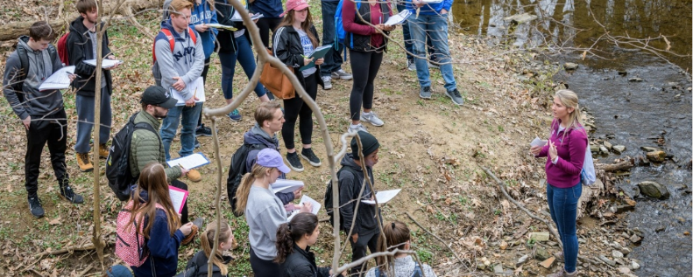

Welcome to the Department of Earth Sciences! We strive to create an equitable, diverse, and inclusive working and learning environment for all in our community. We reject all exclusionary behaviors and bias. As a member of our community when engaged in conversation whether it is in a formal meeting or a more informal setting, we ask you to follow our Norms for Respectful Conversation by:
- Focusing on ideas, using “I” statements, and respecting everyone’s time;
- Encouraging all voices to be heard;
- Respecting all ideas as they are presented and if there are differences of opinion that cannot be resolved, agreeing to disagree;
- Avoiding hostile tones, passive/aggressive comments and behaviors, and directed personal comments;
- Encouraging anyone to speak out if statements made make them feel uncomfortable or are offensive in some way;
- Keeping any personal details discussed confidential;
- At all times being self-aware and encouraging others to engage in positive and supportive behaviors; and
Encouraging active bystander intervention when these norms are not followed.

